Rhino Stacker Instructions

Version：V4.0.8
Date：March 19, 2025
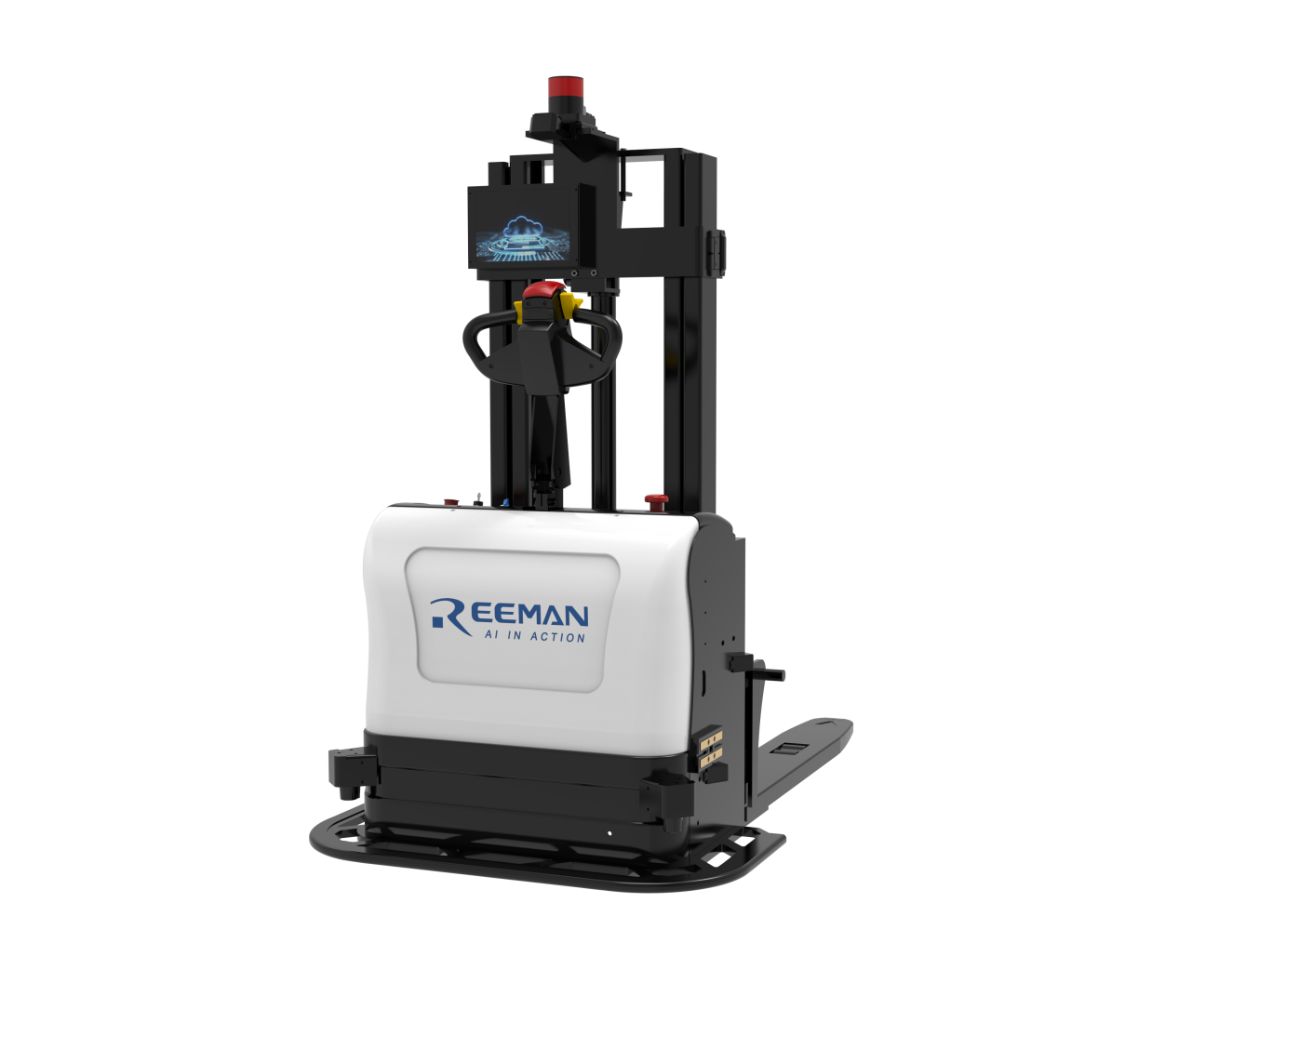

Content
Content 2
1. Product Introduction 4
1.1 Charging Precautions 5
1.2 Structural Parameters 6
①Robot Component Overview 6
② Specifications 6
2. Instructions for Use 11
Mode Switching: Automatic / Manual 13
Automatic Charging 13
Manual Charging (When Battery is Depleted) 13
Emergency Stop Functions 14
2.2 Navigation Deployment 14
2.2.1【Network Connection】 15
2. 2.2【Build a map】 15
2.2.3.【Calibration point】 22
2.2.4.【Navigation route】 31
2.2.5.【Edit Virtual Wall】 34
2.2.6.【Use the machine】 35
3.2.【Edit Map】 60
3.3.【Map Management】 61
3.4.【Settings】 63
3.5.【Debug】 65

1. Product Introduction
The intelligent stacker forklift is an automated stacking equipment equipped with a navigation system. This manual serves as a general guide. We reserve the right to modify the technology of the intelligent stacker forklift. In case of discrepancies between this manual and the actual product, the actual product shall prevail. This manual is for reference only.
1.Precautions for Using the Intelligent Stacker Forklift
- Before operating the intelligent stacker forklift, ensure that you have received relevant training and are familiar with the operation manual and safety guidelines.
- Only trained and certified personnel are permitted to operate the intelligent stacker forklift.
- Familiarize yourself with the navigation system interface and follow the correct procedures for operation.

2.Safety Zones and Obstacles
· Define and clearly mark the safety zones to prevent unauthorized personnel from entering the operation area.
· Ensure that the operation area is free from obstacles or debris so that the intelligent stacker forklift can move and operate freely.
3.Navigation System Calibration
· Regularly calibrate the navigation system to ensure accuracy and reliability.
· Inspect the navigation sensors and equipment for proper functionality and perform necessary maintenance.
- Personnel Safety
· During operation, ensure that all personnel maintain a safe distance to prevent collisions or accidental injuries.
· Warn nearby personnel about the movement of the intelligent stacker forklift and advise them to stay clear of its travel path.
- Emergency Situations and Safety Equipment
· Ensure that the intelligent stacker forklift is equipped with necessary safety devices, such as emergency stop buttons, safety warning lights, and audible alarms.
· Familiarize yourself with the location of the emergency stop button and take appropriate action in case of emergencies.
- Monitoring and Troubleshooting
· Monitor the forklift's operating status and performance, including battery levels and navigation system conditions.
· If any malfunction or abnormality occurs, immediately stop using the forklift and contact maintenance personnel for troubleshooting and repairs.

1.1 Charging Precautions
- Use only the original AC-DC power cable and charger provided with the robot to ensure safe and efficient charging. Using unauthorized equipment may result in electric shock or damage to the robot.
- Do not attempt to disassemble the robot while it is charging.
- Avoid dropping or striking the charging dock, as this may cause damage.
- Do not touch the power cable with wet hands or unplug the charging dock by pulling the power cord directly.
- The charging dock should be placed in a dry area, away from rain or liquid exposure.
- If the robot has not been used for an extended period, charge it approximately every three months to maintain battery performance.
- Do not use the battery for any other devices.
- Do not attempt to touch the output terminals of the charging dock or the robot’s charging port, as this may pose a safety risk.
- The charging dock should be placed against a wall, with at least 2 meters of clear space in front of it, free from any obstructions.
⚠ Special Notice: Improper handling of the battery may result in explosion, fire, leakage, or corrosion. Please strictly adhere to the above precautions.

1.2 Structural Parameters

①Robot Component Overview
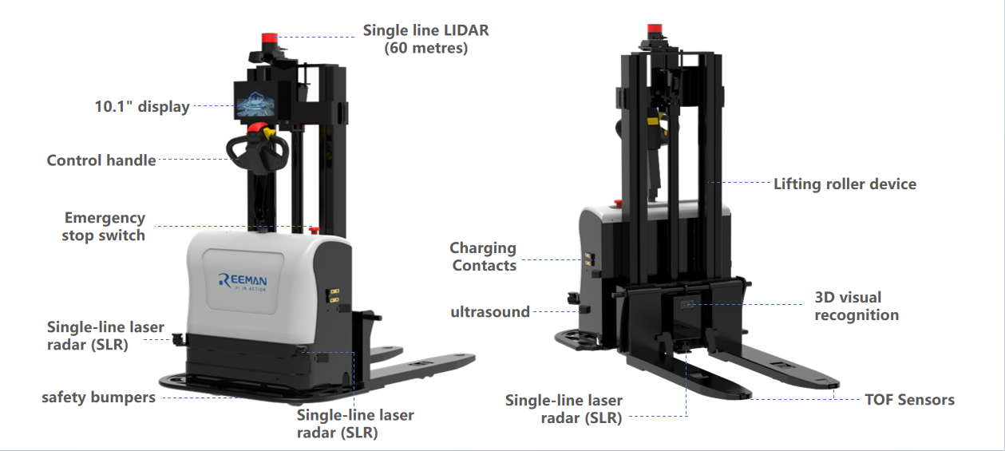

② Specifications

Specifications
Product Model | Rhino
Product Size | 1950mm(L)x950mm(W)x1900mm(H)
Operating System | android（11.0）
Language Support | Chinese, English
Key Start Button*1 | Power Button
Software Emergency Stop | Pause Vehicle Operation, Software Emergency Stop
Hardware Emergency Stop | Release the motor power supply, hardware emergency stop
Display | 10.1-inch display
10.1 inch touch screen | 256.37*174.37*2mm
External I/O Ports | 1 USB 2.0 (MICRO USB)  1 RJ45 network port
Speaker | 4Ω/3W dual channel speaker
Wireless TechnologyAP6255 | Support dual-band 2.4&5G WIFI 802.11b/g/n wireless LAN 11ac 5.15GHz-5.825GHz
Operating System | LINUX
Processor type | Computer motherboard I7 ITX-B100_I726L VER:1.5 (I7-10710U) 10th generation dual network 6 serial ports / Computer motherboard I5 GW7-T10D-V1.2/10310U
Hard disk | 128G high-speed solid state drive
Motor drive | 1.2kw/48V travel motor 800w/48v steering motor
gyroscope | Single-axis high-precision attitude sensor
Single-line main laser radar | Laser wavelength 905 nm Working area 360 degrees 60M
Single-line obstacle avoidance laser radar*3 | Laser wavelength 905 nm  Working area 360 degrees 25M
Industrial grade pallet image recognition (IP65)*1 | 8m
switch | 100M 8-port Industrial grade
safety edge | Front safety anti-collision edge
4G router to 2.4G WIFI | 4GCPE-M6
512AN_HMW module Intel WIFI | Support dual-band 2.4&5G WIFI&BT4.1 802.11b/g/n wireless LAN 11ac 5.15GHz-5.825GHz
Battery Type | Lithium iron phosphate battery 48V/30Ah
Rated usage time | 6 hours (full load)  8 hours (no load)
Drive mode | Electronic Steering & AC Servo Motor
driving style | Walk-behind & Automatic
Maximum load | 1500KG
Vehicle weight (including battery) | 870KG
Body size | 2028mm(L)x1126mm(W)x1900mm(H)
Fork size | 1131mm/325mm/60mm
Fork outer width | 685mm
Fork lifting height | 2500mm
Minimum height of fork | 85mm
Maximum height of mast during operation | 3050mm
Wheelbase center ground clearance | 30mm
turning radius | 1500mm
Tire type (load wheel/drive wheel/training wheel) | polyurethane wheel
Tire size, front  Tire size, rear  Tire size, training wheels | 210mmx70mm  80mmx70mm  100mmx50mm
Number of wheels Front wheels/Rear wheels (x=driving wheels) | 1//2//4
Front wheel track | 866mm
Rear wheel track | 525mm
Aisle width pallet 1000*1200 (1200 across fork placement) | 2200mm
Aisle width pallet 800*1200 (1200 placed along the fork) | 2100mm
Travel speed full/unloaded | 2.8km/h, 3.6km/h
Lifting speed full/no load | 140mm/s
Lowering speed full/no load | 101mm/s
Climbing speed full/no load | 8%，15%
service brake | Electronic braking
Drive motor power | 0.8KW
Increase motor power | 2.2KW
Lithium battery voltage | 48V
Lithium battery weight | 15KG
Noise level at the driver's ear in accordance with DIN 12053 | <70DB(A)
Charging method | automatic charging
Certification | CE

2. Instructions for Use
2.1 Know Your Robot
Turn on the machine: Insert the key and turn it to the right. The buzzer will emit a short "beep" sound, and the internal light bar of the machine will light up. Wait for the machine to turn on. 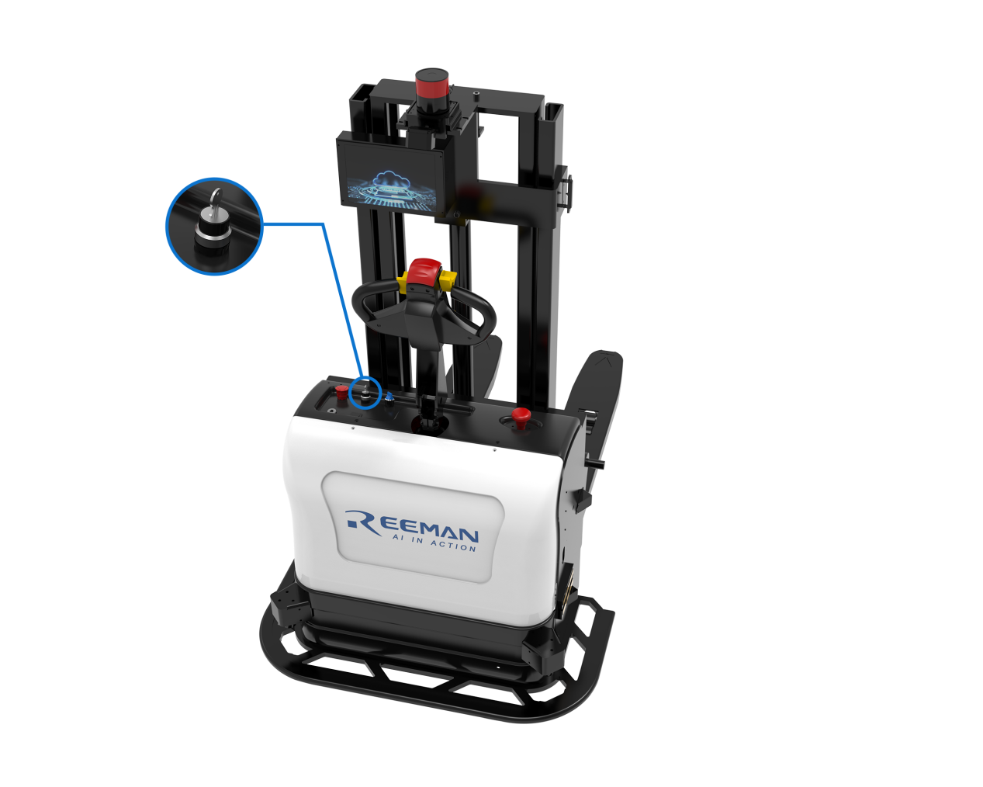
Shutdown: Turn the key to the left, there will be a beep and the display will turn off first, and then the motor will be powered off.
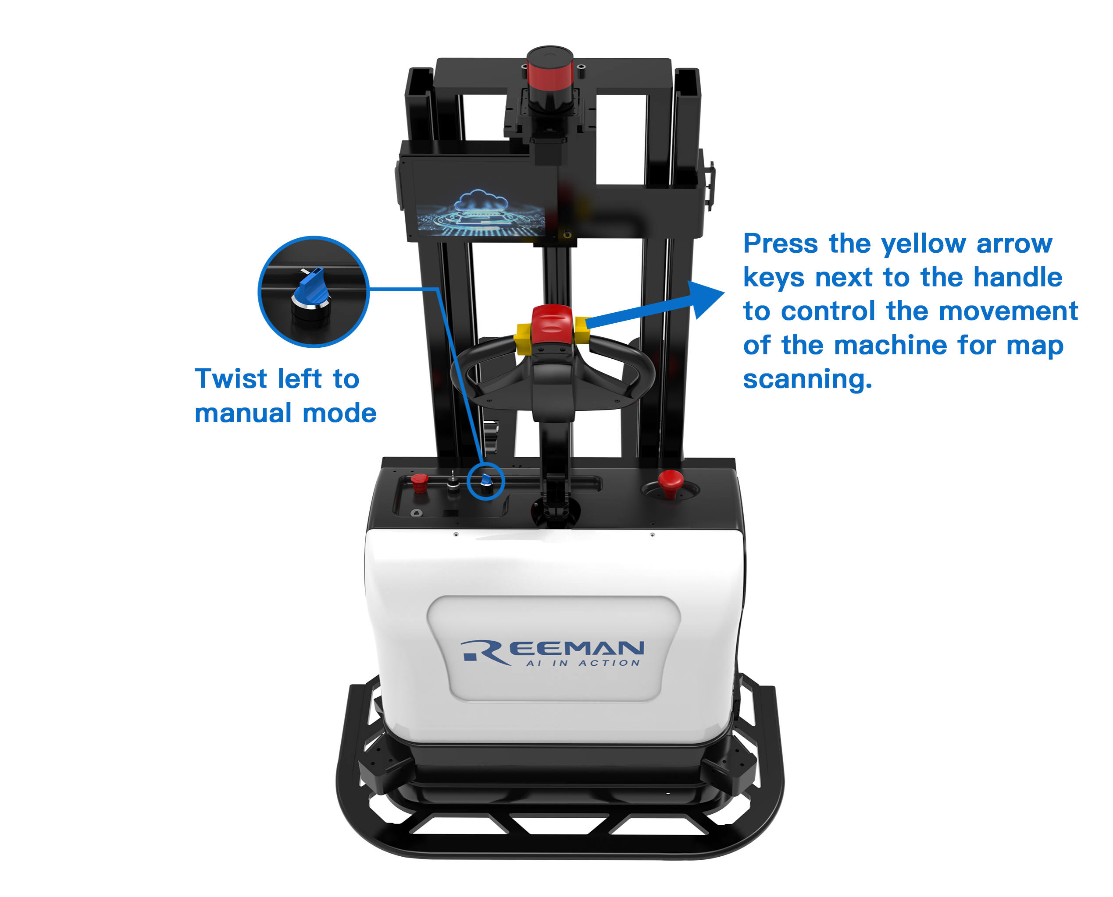

Mode Switching: Automatic / Manual
- When the handle display screen is on, turning the manual/automatic mode switch to the left enables manual control mode, while turning it to the right enables automatic control mode.
- If the handle display screen is off, a card swipe is required to activate the screen. After that, you must enter the password and press the confirmation button to switch to manual mode.

Automatic Charging
- When the battery level reaches the preset low-power threshold, the system will automatically return for charging.

Manual Charging (When Battery is Depleted)
- The charging port is located on the left side of the intelligent stacker forklift (referencing the vehicle's front as the center). Simply plug in the charger to start charging.
- Note: If the battery enters low-power protection mode, connect the charger to the forklift before plugging it into the power source.

Emergency Stop Functions

Soft Emergency Stop
- Pressing the soft emergency stop button will halt all machine actions.
- After releasing the button, you can resume the task by tapping the "Resume Task" option on the screen (except when in docking mode).

Hard Emergency Stop
- Pressing the hard emergency stop button will halt all machine actions.
- After releasing the button, you can resume the task by tapping the "Resume Task" option on the screen (except when in docking mode).
- Switching to manual mode after a hard emergency stop requires a card swipe and password entry before operation can resume.

2.2 Navigation Deployment
Note: The following content is an introduction to all functions of the robot deployment background. The functions that must be operated are points 1, 2, 3, and 4 as shown below. Other functions depend on specific scenarios and usage.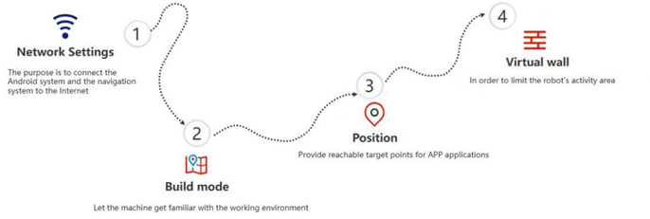

2.2.1【Network Connection】

On the screen, find the software named aging-ros3 and open it. Follow the steps shown in the picture. If the WiFi password already exists, just click <Confirm>
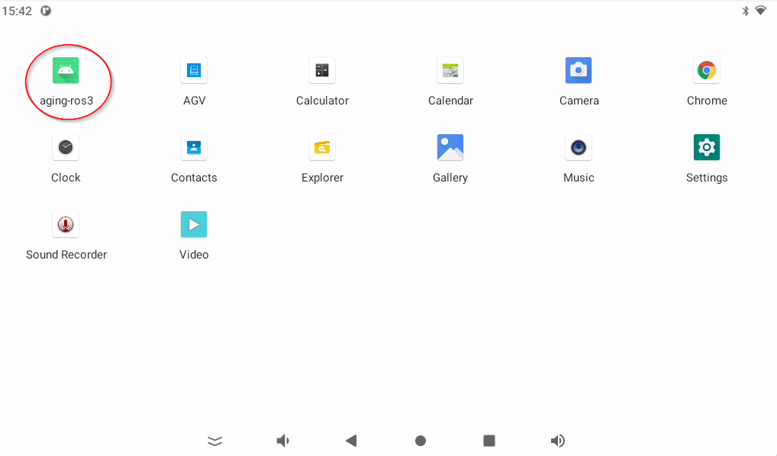
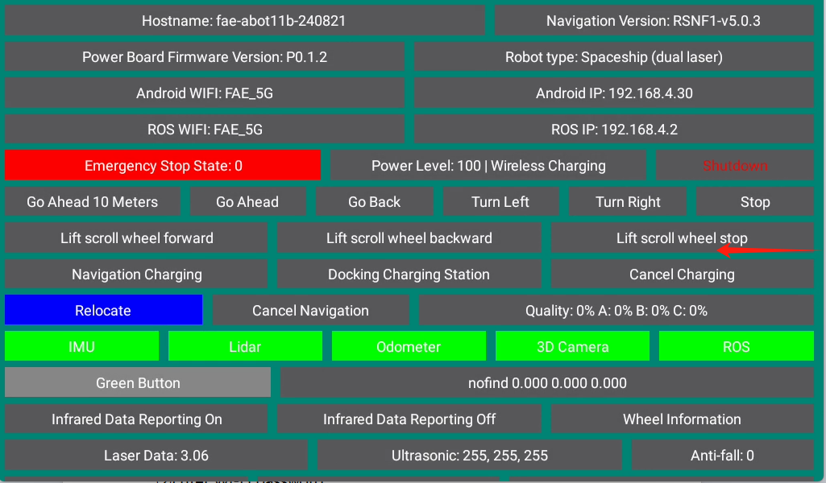

2.2【Build a map】

● The purpose of building a map is to allow the robot to understand the working environment
● The robot needs to scan the actual environment and build an "original map" so that the machine can find its own position during navigation by comparing the real-time scan with the original map.
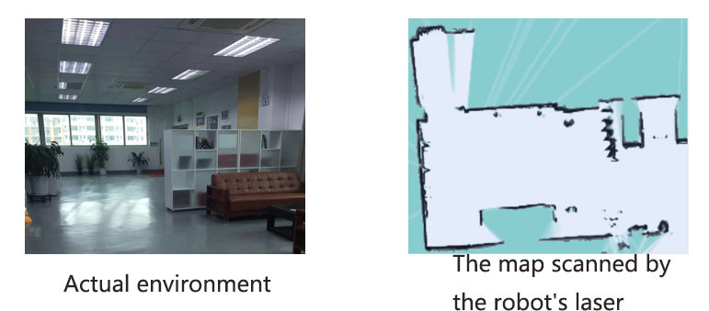

The viewing angle of the laser radar is 360°, and the scanning range is the horizontal plane at the height of the radar; the scanning distance is 60m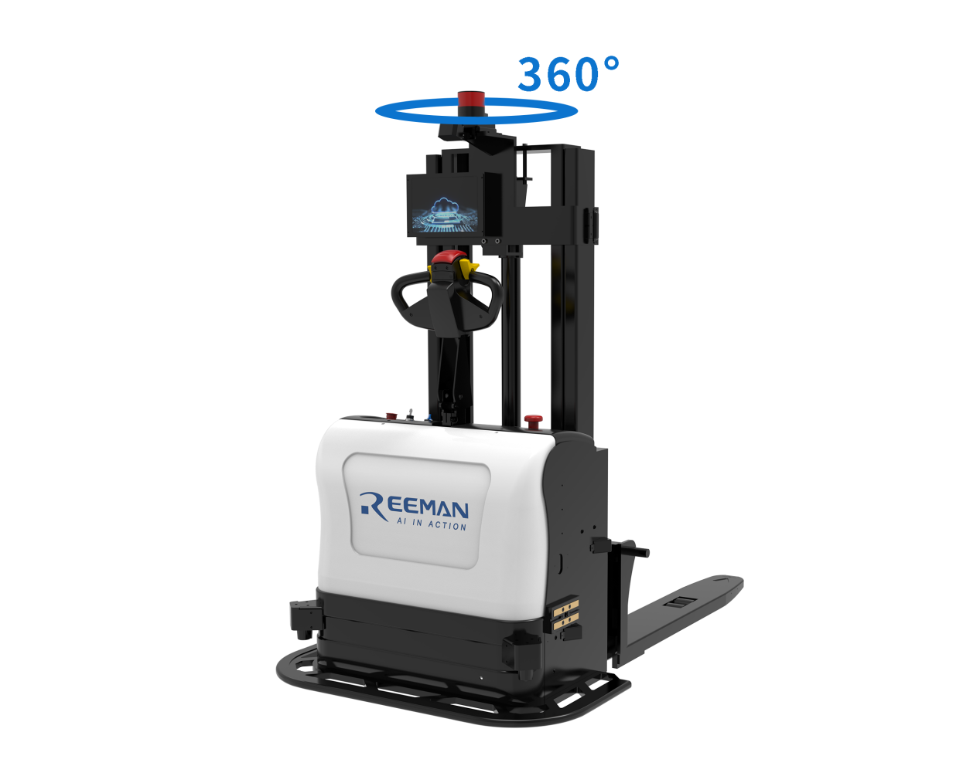

- Please enter the map creation page according to the following sequence
Make sure the computer and the robot are connected to the same WiFi, open the browser, enter the navigation IP address displayed on the aging-ros3 application in the address bar, and press Enter to connect to robot.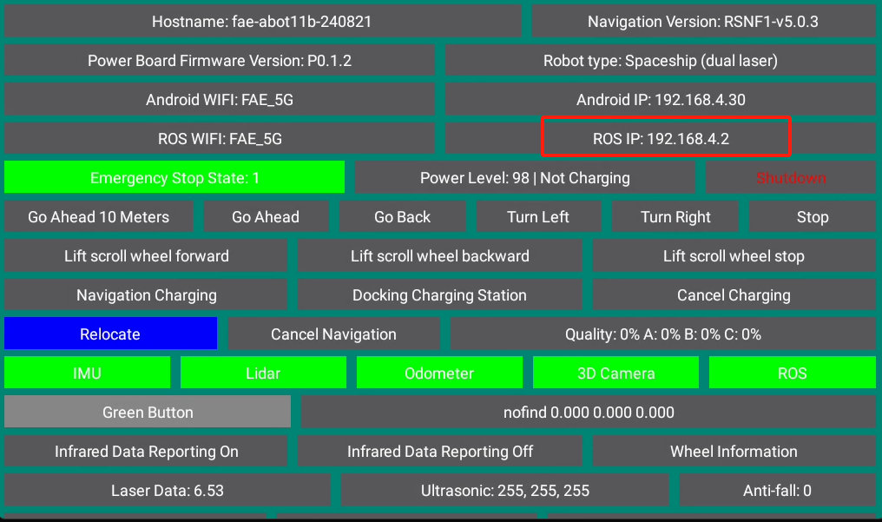
- After entering the laser mapping screen, as shown in the figure below, turn the knob to the left to the manual mode, and press the yellow direction key next to the handle to control the machine to move and scan the map.

3. First, control the robot to rotate in place for a circle to scan the surrounding environment. Do not rotate too fast. After a circle, continue to push the robot to scan according to the actual situation of the environment. In narrow areas, you can go in a straight line. When walking, you need to pay attention to the intersections. Slowly rotate the machine 90 degrees in place to face the gap to clear the feature points, and then slowly turn back to continue scanning; in open areas, you can follow a U-shaped route as follows
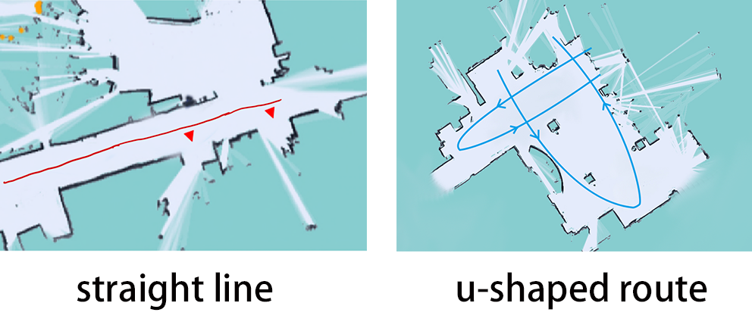
4. When controlling the robot to scan the map, pay attention to whether the laser matches the actual terrain. If not, stop and wait for a while until the laser matches the actual terrain before continuing. As shown in the following figure: yellow is the real environment scanned by the laser, and black is the generated map outline.
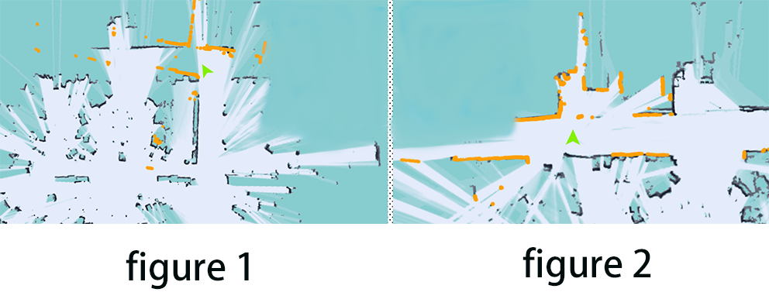
Figure 1: The laser does not match the terrain (when the laser does not match the terrain, you need to stop and wait for the laser to match the terrain before continuing to push the robot to build a map)
Figure 2: Matching the laser to the terrain (some areas require the robot to turn around to scan clearly, such as wide terrain and rooms)
- After you have scanned the environment where the robot needs to work, do not move the machine. Just observe whether the map is neat and has no ghosting and matches the actual terrain. If there is no obvious misalignment, click [Complete Composition]. If there is misalignment, wait for a while and the algorithm will correct it. If the correction is not successful within 3 minutes, consider rebuilding the map.
Note：
1. Select a place with obvious feature points and neat terrain as the starting and end point of the scan, and slowly turn around in place at the beginning to scan the surrounding environment clearly.
2. When pushing or controlling the machine, walk slowly and always observe whether the laser matches the terrain. If there is a mismatch, you need to stop and wait for the laser to match the current terrain.
3. After the machine reaches the end point, observe whether the map is neat and has no ghosting and matches the actual terrain. If there is no obvious misalignment, you can click [Complete Composition]. If there is a misalignment, please wait for a while and the algorithm will correct it. If the correction is not successful within 3 minutes, consider rebuilding the map.

2.2.3.【Calibration point】
● The purpose of calibrating points: It is convenient for the business layer to let the robot navigate to the specified location through the point name. (When calibrating the point, please first determine whether there are obstacles within the laser obstacle avoidance range of the point to ensure that the machine reaches the point).
● The points that can be used by this model are as follows:
Packing point, delivery point, route point, charging pile, elevator waiting point, elevator boarding point, and elevator exit point.
● Marking path: Pull the machine to the appropriate position, click the web navigation route-current position
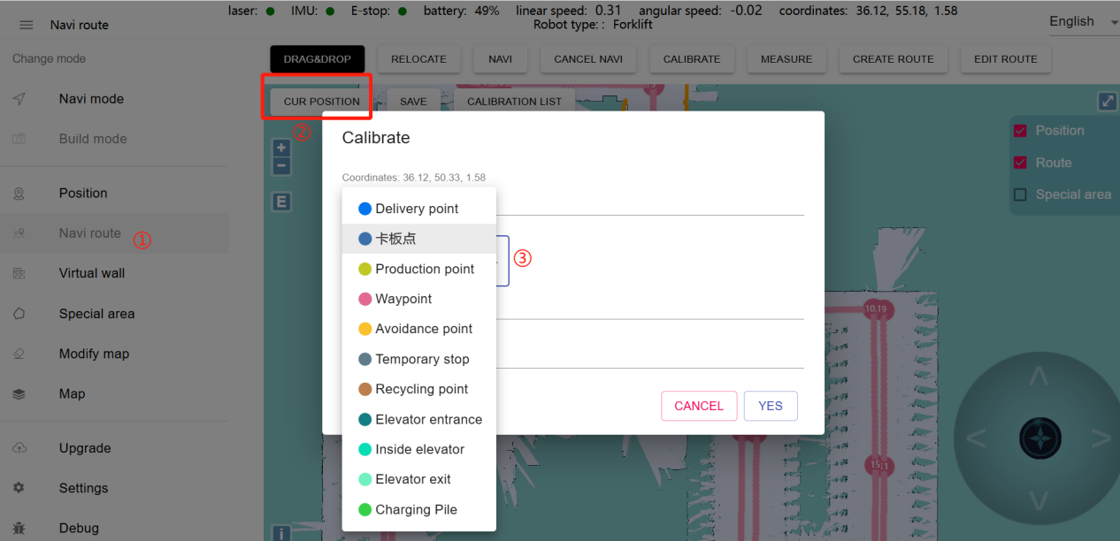

● Point calibration method:
① Move the forklift to the pallet placement position.
② Observe the map interface to determine whether the current positioning of the machine is accurate (accurate: the yellow laser data and the black obstacle completely overlap).
③ In the "Navigation Route" mode, click the "Current Position" button to set the point, as shown in the steps below.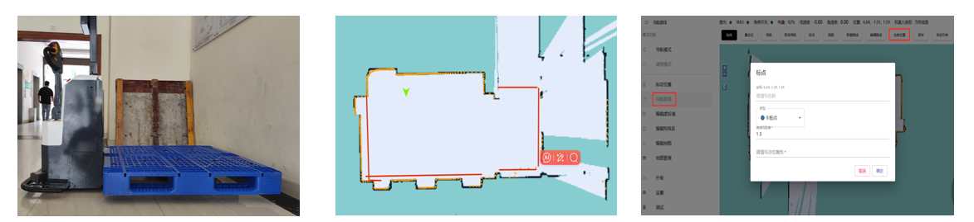

④Set the name and type of the point.
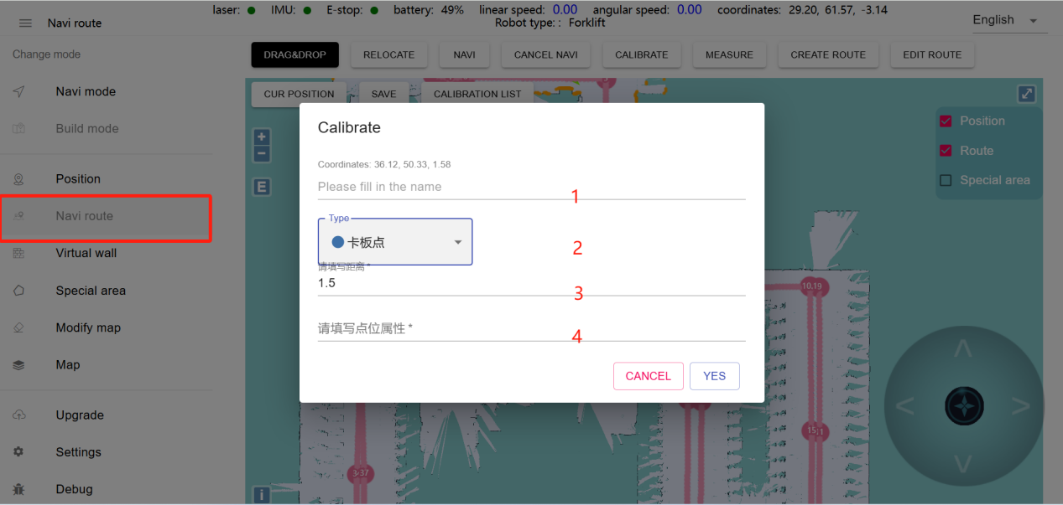

● Point attributes
Add attribute address: https://navi.rmbot.cn/forklift
Add attribute page:
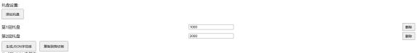
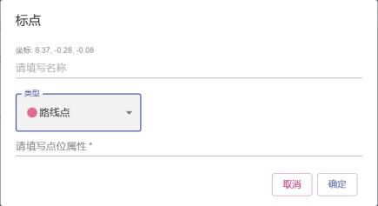
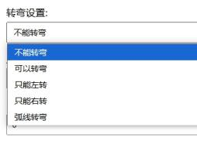
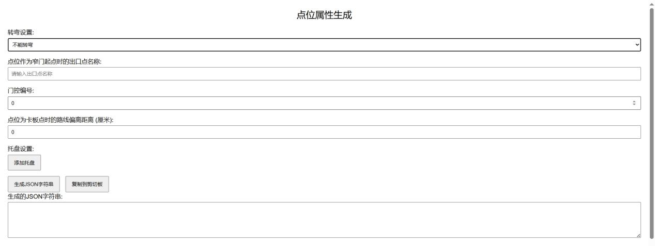
After setting the properties - click to generate JSON string - click to copy to clipboard - paste to the point property column when punctuating.
● The role of the property
Turning setting: All pallet docking points can turn by default, and the starting point of the reverse section must be set to turn. When adding the turning property, make sure that there is enough turning space at the location.
Narrow door: used to pass through a narrow door of 1.6~1.8m. Mark the route points on both sides of the narrow door at a distance of 60cm from the front of the vehicle to the narrow door, and set the other point name as the narrow door exit in the property column.
Gate control: Enter the number of the automatic door (you need to bind the gate control in the forkliftAPP first, and you need to install the gate control module).
Route offset distance: set the distance to the left and right when reaching the pallet point (used in special scenarios).
Add a pallet: Click Add a pallet to set the pallet height (unit: mm). One point can add multiple heights corresponding to the number of shelves (the height set when marking should be 1.5~2cm higher than the shelf height)
● Pallet point
The function of the pallet point: It is the location for picking up and placing pallets. The docking point can be generated according to the position and angle of the marked pallet point.
Calibration method: Navigation route-Current position-Click the inverted triangle arrow to select the pallet point
Point name: The name of the point can be customized.
Please fill in the distance (m): Here you can set the distance between the automatically generated docking point and the pallet point, as shown in the figure below:
The pallet point is perpendicular to the route (turn 90 degrees to dock the pallet), and the docking distance is set to 1.7.
If the pallet point is parallel to the route (turn 180 degrees to dock the pallet), the docking distance is set to 2.6.
If the pallet point is parallel to the route but the "route setting is reversed", the docking distance is set to 1.7.
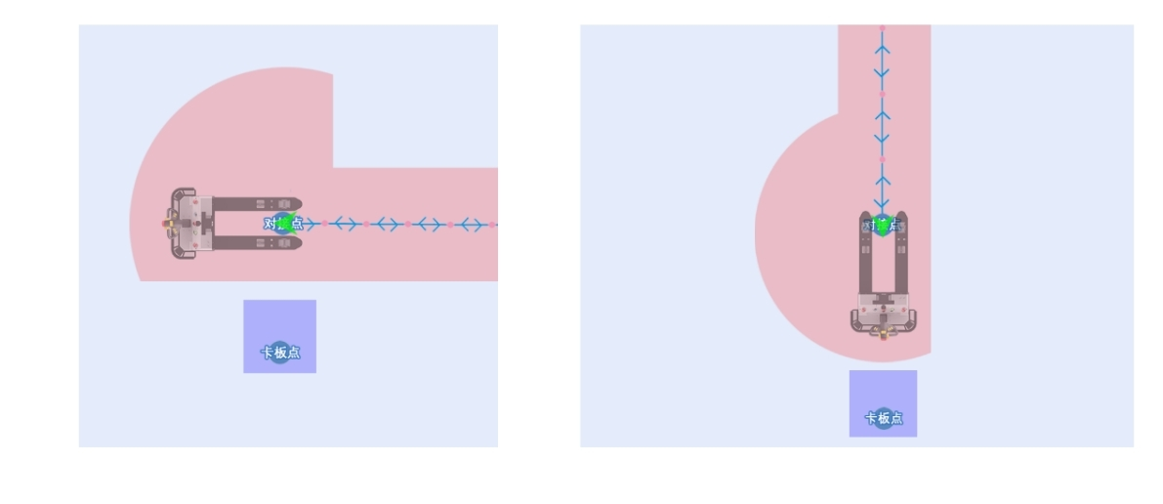
Shelf height: measure the height of the shelf separately (for each layer) - click to add multiple pallet heights in the attribute generation URL (related to the actual number of layers used) - conveniently enter the actual height + 20mm (such as 1m shelf input height: 1020) - generate a string - copy to the clipboard - paste it to the web-side pallet point attribute bar (if the height is not set, the default height is 0).
Available attributes: only the pallet height attribute can be set, and setting other attributes will not take effect.
The role of the docking point: the docking point is the docking point of the pallet point. The machine will pick up and place the pallet in a docking manner, including identifying the pallet and judging whether the pallet placement area is occupied (identification will lower the fork arm detection, and this function can be turned off in the stacker APP).
● Route point
The role of the route point: used to plan the route, and the machine's running route is planned by adding route points.
Calibration method: navigation route-current position-click the inverted triangle arrow-select the route point.
Point name: customize the point name.
Available attributes: steering attribute, narrow door attribute, gate control attribute.
● Production point
The function of the production point: the position where the machine is idle.
Calibration method: Navigation route-current position-click the inverted triangle arrow-select the production point.
Point name: customize the name of the point.
Available attributes: steering attribute.
● Charging pile
The function of the charging pile: when the machine power is lower than the set low power, it will trigger low-power recharging.
Calibration method: Navigation route-current position-click the inverted triangle arrow-select the charging pile.
Point name: customize the name of the point.
Point attribute: steering attribute.
Route attribute: the last section of the route connecting the charging pile needs to be set as the charging pile route.
● Machine elevator setting:
Prerequisite: The elevator control module must be deployed in advance.
Elevator requirements:
①The elevator control must be turned on in the Forklift APP settings.
②The waiting point, elevator point, and elevator exit point must be marked on the map.
③There are multiple maps in the map management and the map name is named after the floor. For example, the map name of the 8th floor must be set to "8".
(Note: If the machine needs to take the elevator, there needs to be a 3m*3m space outside the elevator. The minimum width of the elevator is 1.8m and the minimum length is 2.5m).
● Elevator exit point: The elevator exit point must be in front of the elevator. When the machine takes the elevator to the designated floor, the map will automatically switch.
(Note: If the machine exits the elevator backward from the tail, the elevator exit point must be set at a position 60cm away from the most protruding part of the elevator door. If the machine head exits the elevator first, the elevator exit point must be set at a position 60cm away from the most protruding part of the elevator door from the tail of the forklift).
● Waiting point
The function of the waiting point: used for elevator control. The machine will adjust its direction when it arrives at the waiting point, facing the elevator point and calling the elevator. After the elevator arrives, it will enter the elevator in a docking manner.
Calibration method: Calibrate the waiting point at a distance of 70cm from the elevator head in the middle of the elevator. Navigation route-current position-click the inverted triangle arrow-select the waiting point.
Point name: customize the point name.
Available attributes: The steering attribute needs to be set to "steering".
● Elevator boarding point
The function of the elevator boarding point: used for elevator control, it is the position of the machine when it is in the elevator.
Calibration method: pull the machine into the elevator, and calibrate the elevator boarding point at a distance of 50cm from the front of the vehicle to the elevator (the docking obstacle avoidance distance in the forklift APP cannot be greater than 50cm, otherwise the distance needs to be increased).
Navigation route-Current position-Click the inverted triangle arrow-Select the elevator boarding point.
Point name: Customize the name of this point.
Available attributes: No attributes need to be set.
● Elevator exit point
The function of the elevator exit point: used for elevator control, it is the position of the machine when it exits the elevator.
Calibration method: pull the machine to the middle of the elevator door with the front of the vehicle facing the elevator. It is recommended to calibrate the front of the vehicle 60cm away from the elevator. It is also necessary to ensure that there is enough space for the machine to turn or turn around and there are no obstacles within the laser scanning range when turning.
Navigation route-Current position-Click the inverted triangle arrow-Select the elevator exit point.
Point name: Customize the name of this point.
Available attributes: The steering attribute needs to be set to "Steering".

2.2.4.【Navigation route】
● Function: After connecting the points into a route, the machine can run according to the route to pick up and place goods.
● Connection method: Navigation route-New route-Click the mouse to select the points to be connected in sequence. For example: Click A→B→C in sequence to generate a one-way route of A→B→C.
Click A→B→C→B→A in sequence to generate a two-way route of A↔B↔C.
(Note that the pallet point cannot be connected to the route, just connect the corresponding docking point to the route)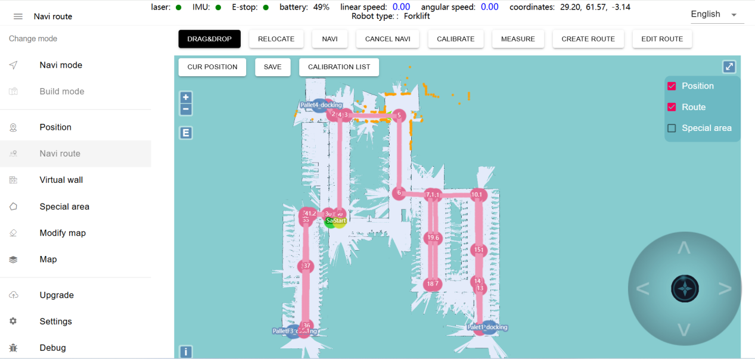
● Route attributes
Add attribute address: https://navi.rmbot.cn/forklift
Add attribute page:
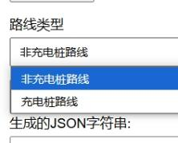
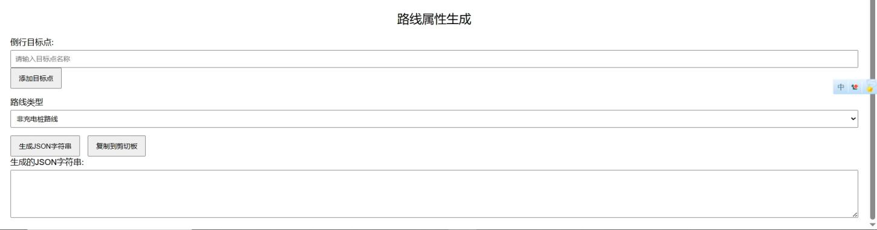
● The function of route attributes: You can set the direction of the machine on this route, such as forward or reverse, and you can set the type of this route, such as non-charging pile route or charging pile route. (The default route type is non-charging pile route, and the last route connecting the charging pile needs to be set as charging pile route)
● How to add route attributes:
Path: Open the attribute URL-enter the reverse target point-click Add target point-select route type-generate JSON string-click Copy to clipboard-enter web background-navigate route-edit route-select the route to add attributes-paste the string into the attribute column-click Save.
If the bidirectional route A↔B needs to make the A→B running direction reverse, enter the name of point B into the reverse target point, generate a string and paste it into the attribute column of A↔B.
(If the distance between points AB is less than 1m, and there is no automatically generated small pink dot after connecting the route, the reverse will not take effect. You need to manually mark a route point between points AB and connect the line to take effect. When selecting the route, you need to frame the middle route point, and you cannot select points AB).

2.2.5.【Edit Virtual Wall】
Function: Used to limit the activity area of the machine
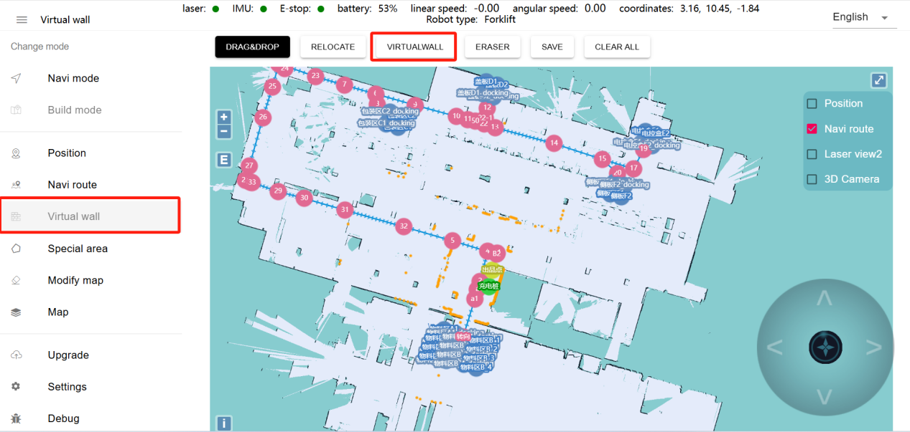
① Drag: You can zoom, pan and rotate the map. Shift+Alt+left mouse button can rotate the map. Press Ctrl+left mouse button to select a rectangular area, and the virtual wall in the area will be cleared
② Virtual wall: Click two locations to draw a virtual wall between the clicked locations
③ Eraser: Circle the virtual wall you want to clear
④ Save: Only click Save to store the drawn virtual wall
⑤ Clear: If you are not satisfied with the current virtual wall, click the Clear button to clear all virtual walls (you need to click the Save button to take effect)

2.2.6.【Use the machine】

Find the software named "stacker" on the machine screen and open it. After opening it, you will see the following screen

front page

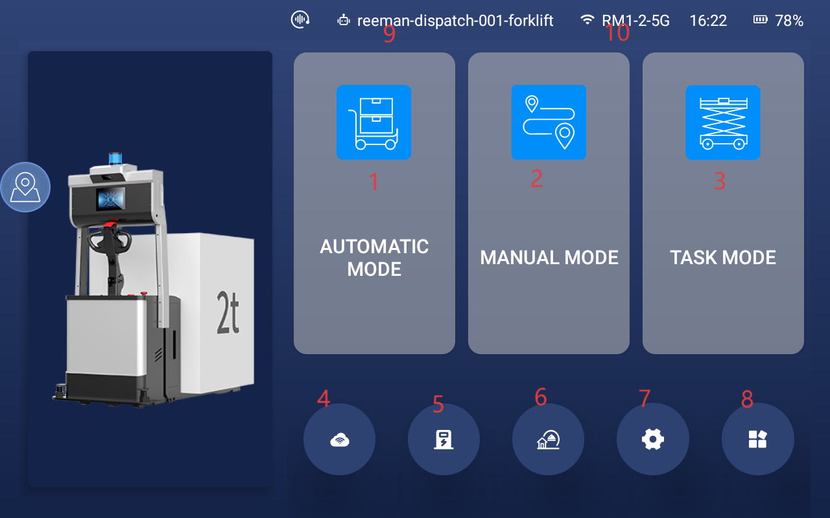

(The picture is for reference only, the actual load is subject to the actual situation)

① Automatic mode

② Manual mode

③ Task mode

④ Network connection

⑤ Navigate to the charging station

⑥ Navigate to the production point

⑦ Settings

⑧ View the stacker information

⑨ Unique machine number, click multiple times to exit the APP

⑩ Current network, current time, current power in order

② Automatic mode
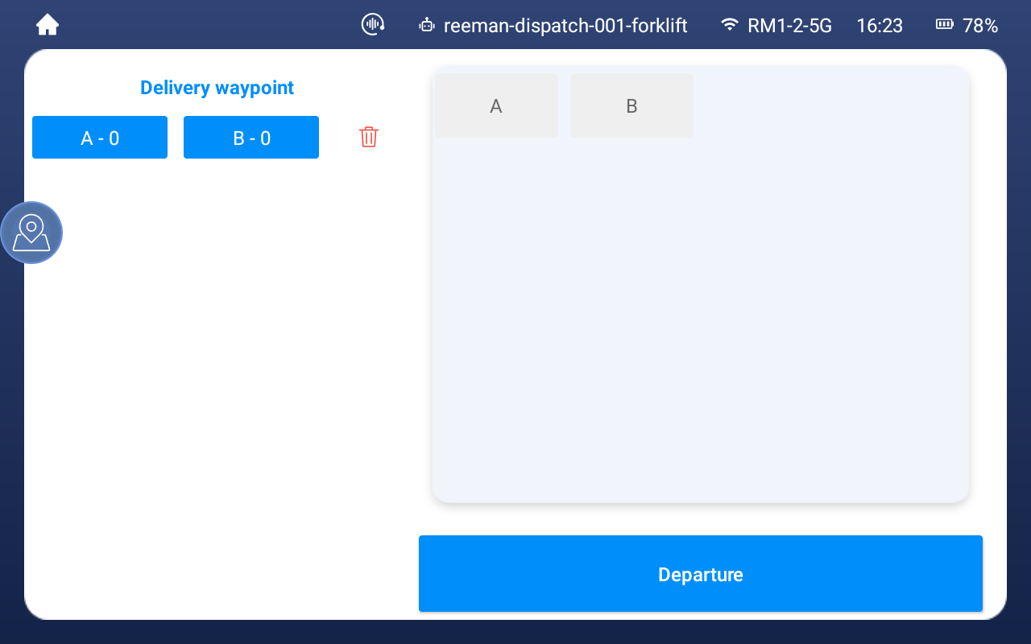
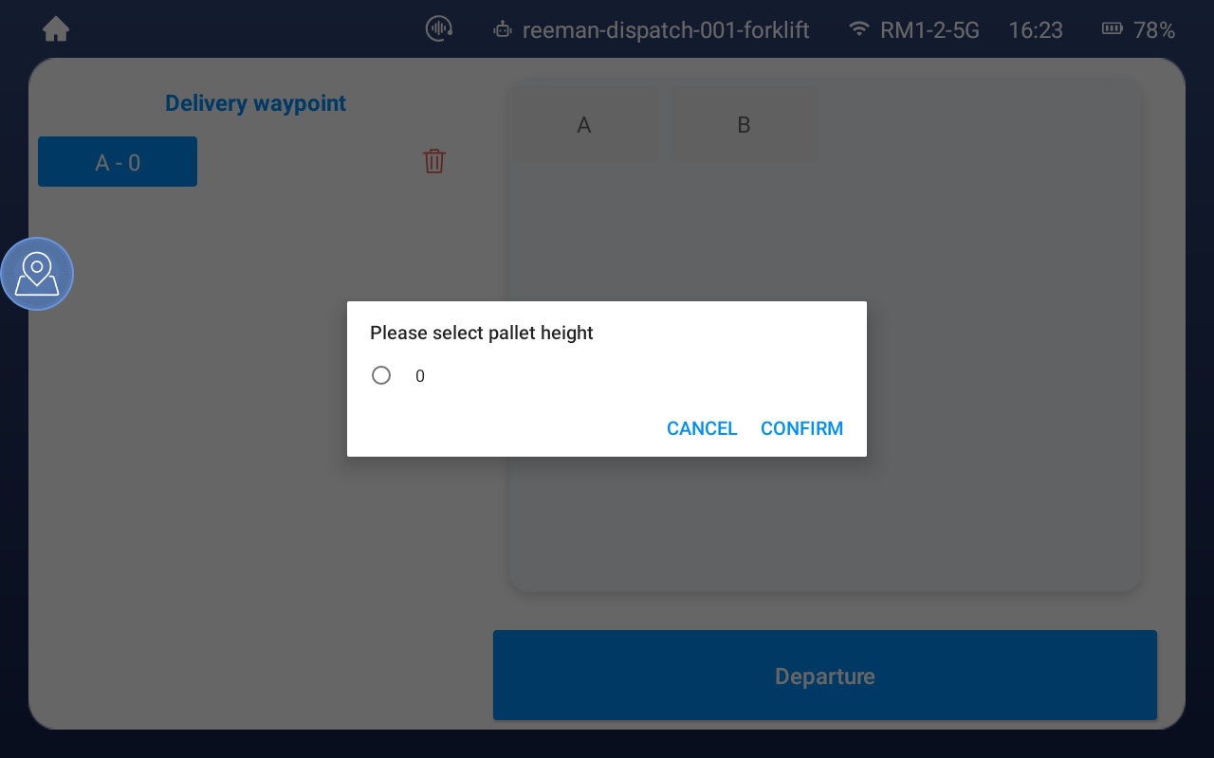
As shown in the distribution point on the left side of the above figure, A0-0 and B-405 points indicate that the calibrated pallet points will be displayed in this area.
Click the point and select the height of the point in the pop-up window. As shown in the figure, the two points A-0 and B-405 are a group of tasks. The first one is the pallet pick-up point and the second one is the distribution point. Click the red trash can to delete the task. Multi-task distribution can be performed (such as AB as a group and CD as a group, then the machine operation path is A→B→C→D→production point).

③ Manual Mode
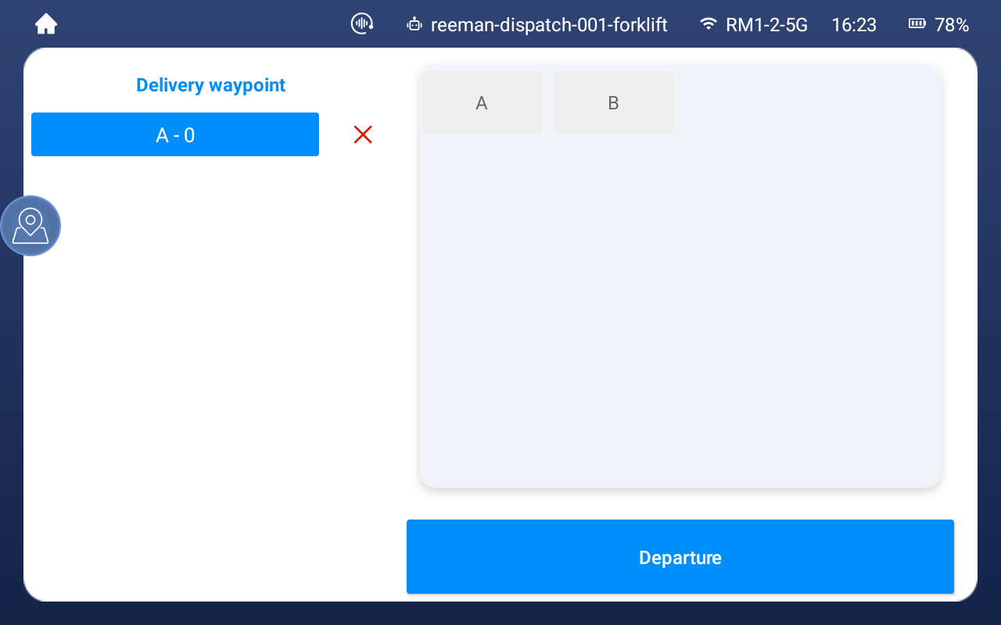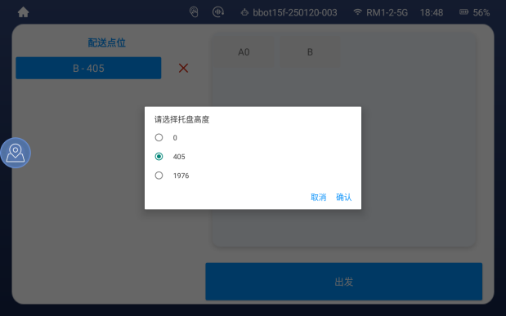
In manual mode, you need to manually control the forklift to the route, then select a destination point and select the height in the pop-up window. Click Start, and the forklift will automatically transport the pallet to the destination point. After the delivery is completed, the forklift will return to the production point.
As shown in the figure above, B-405 indicates that the calibrated pallet point is displayed at the delivery point on the left.
Only one delivery point can be selected, and only a single task can be performed. After the task is completed, return to the production point.

④ Task Mode
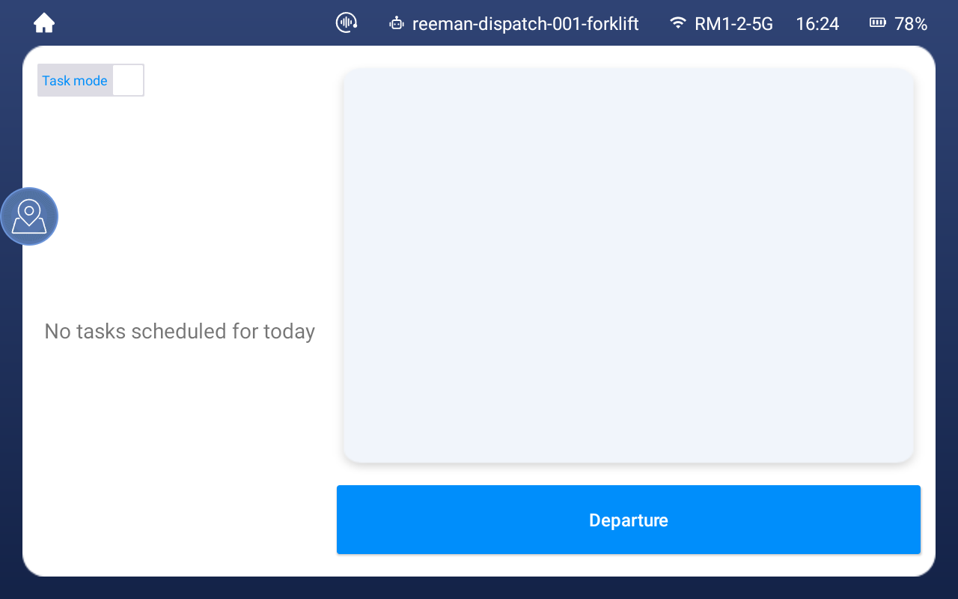
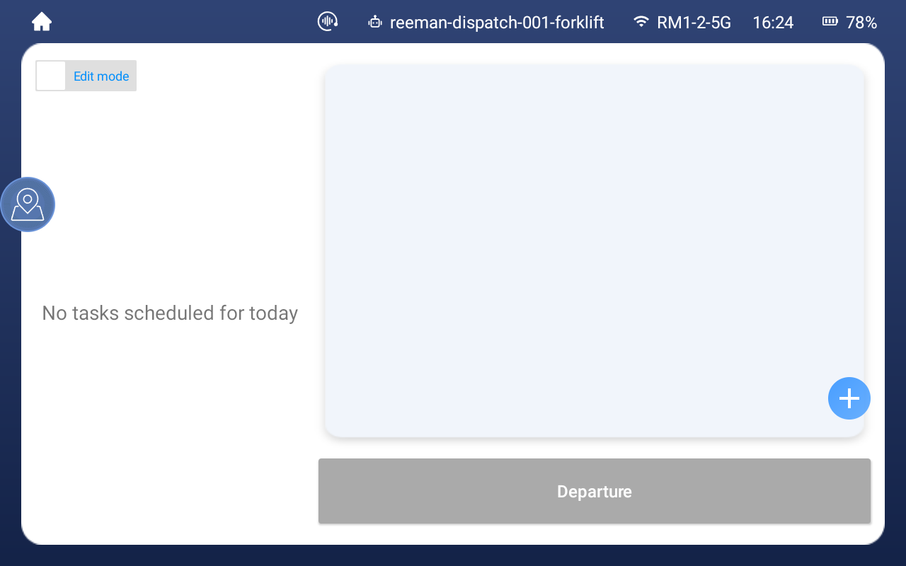
First click "Task Mode" to switch to editing mode, then click "Plus Sign" to create a new task.
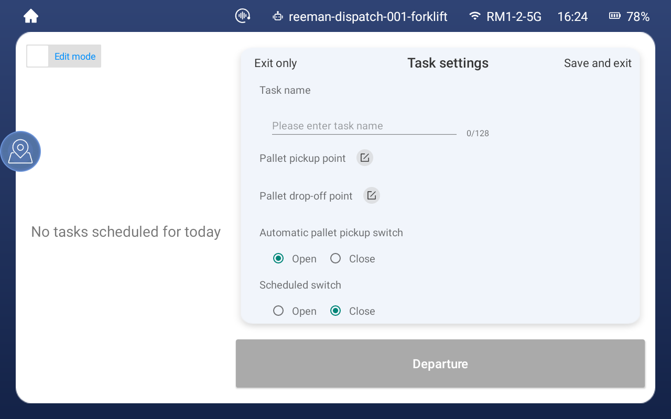
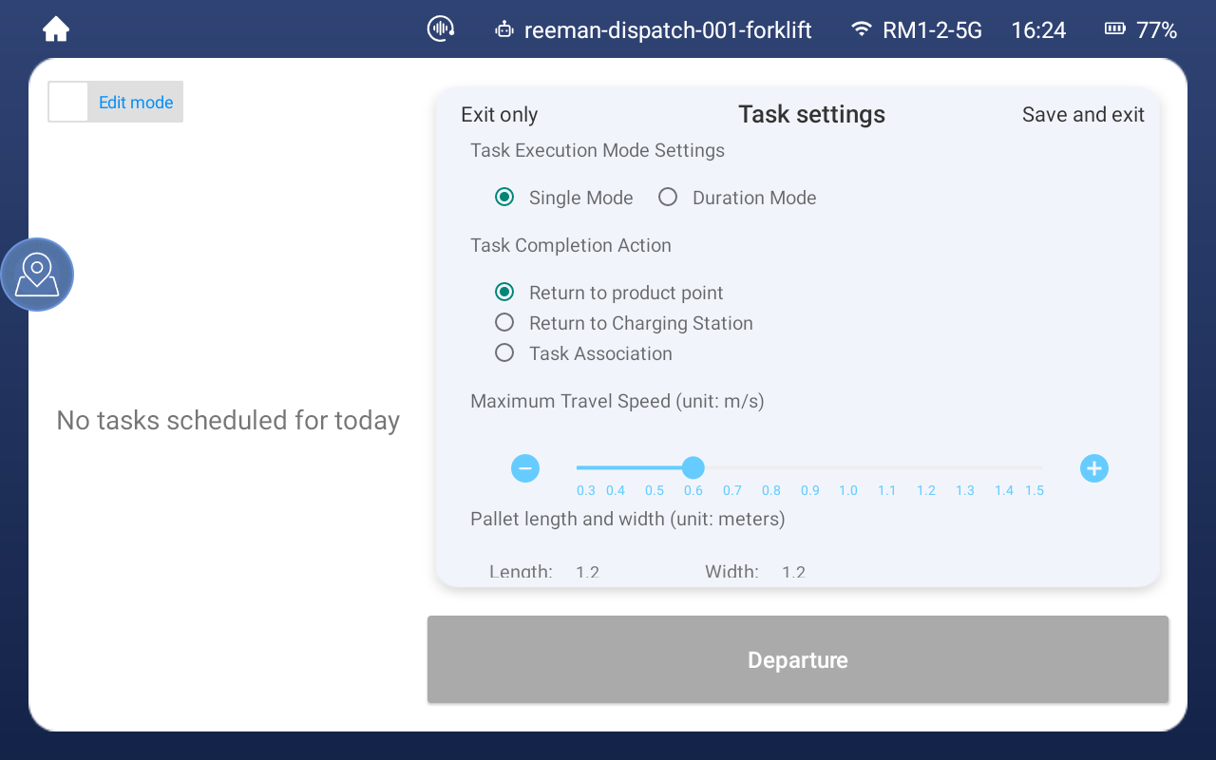
Set the task name - select the pickup point and drop-off point (multiple selections are allowed) - click Save and exit.
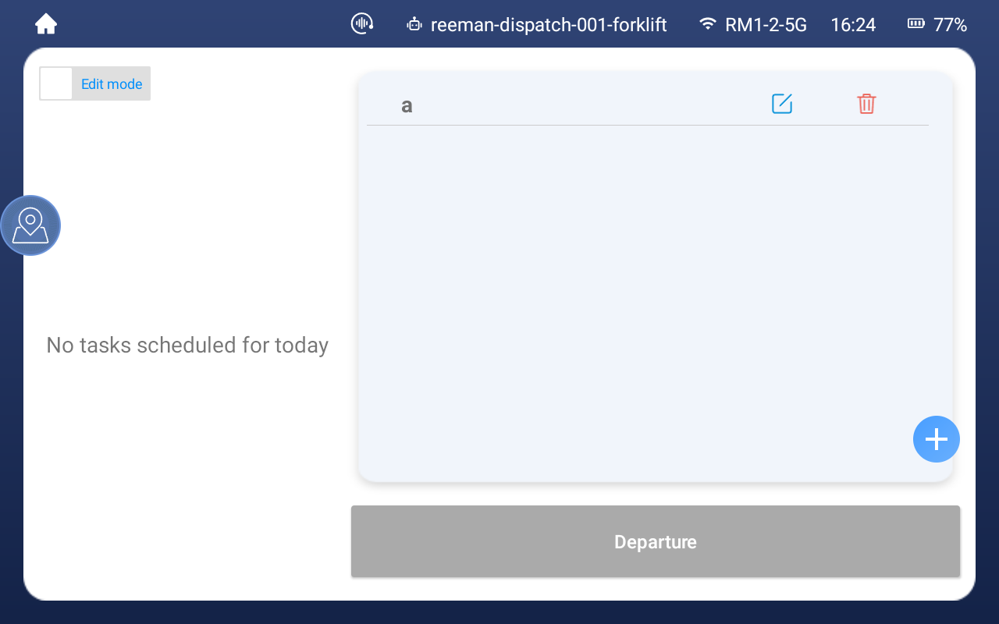

After creating a new task, switch to task mode - select the task and click to start
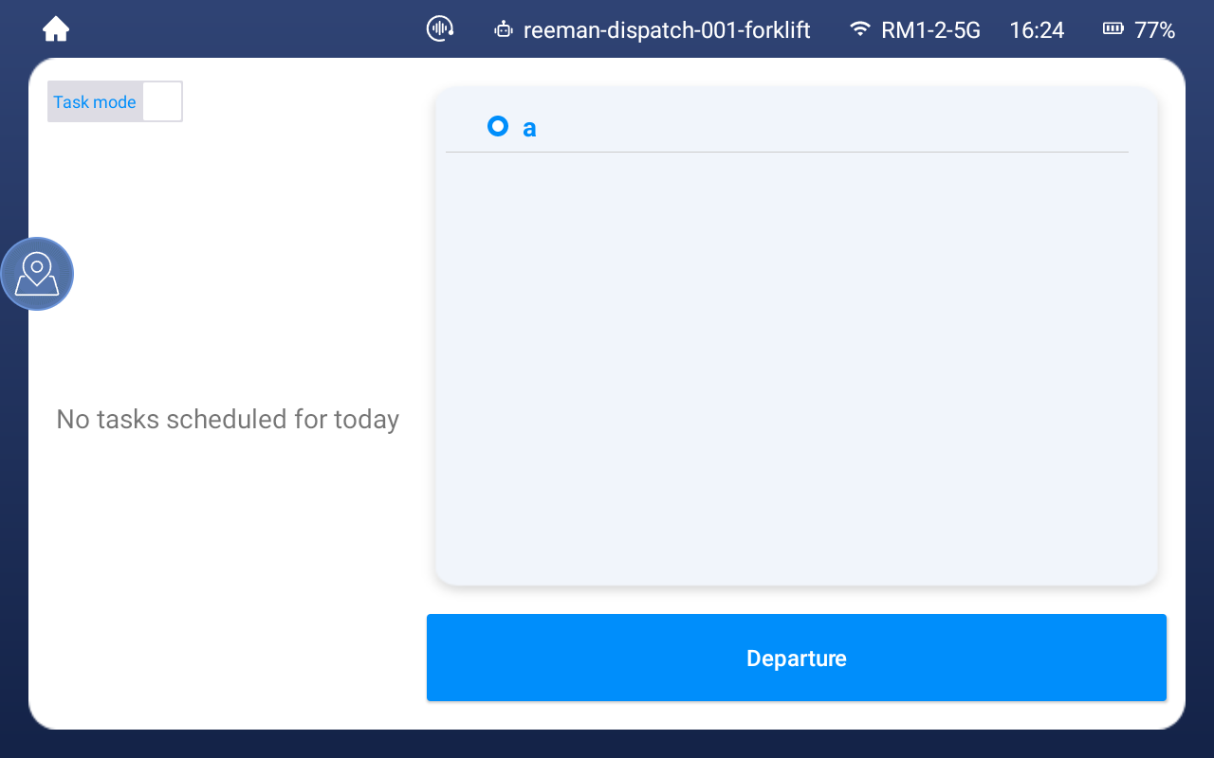

⑤ Setting
(1) Basic settings
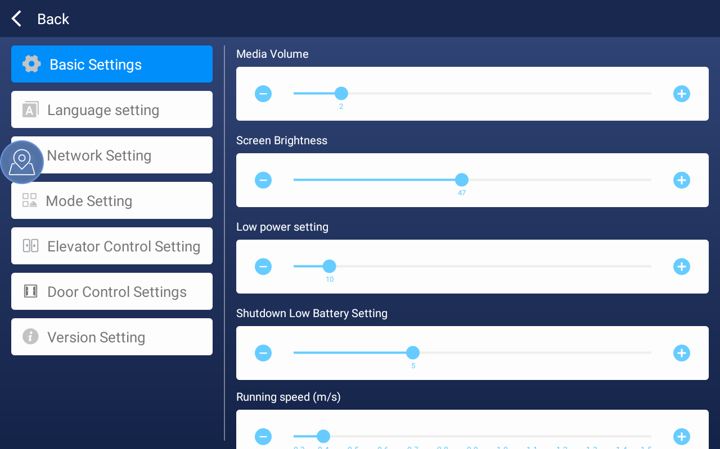
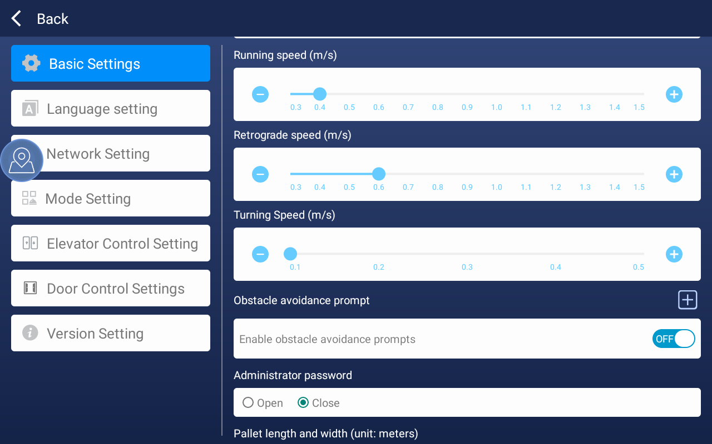
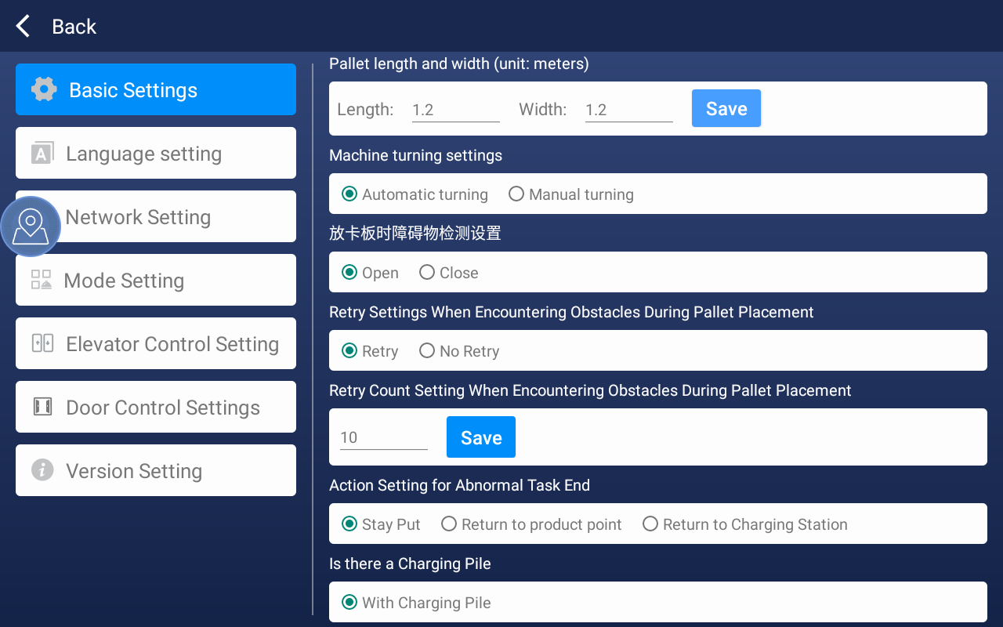
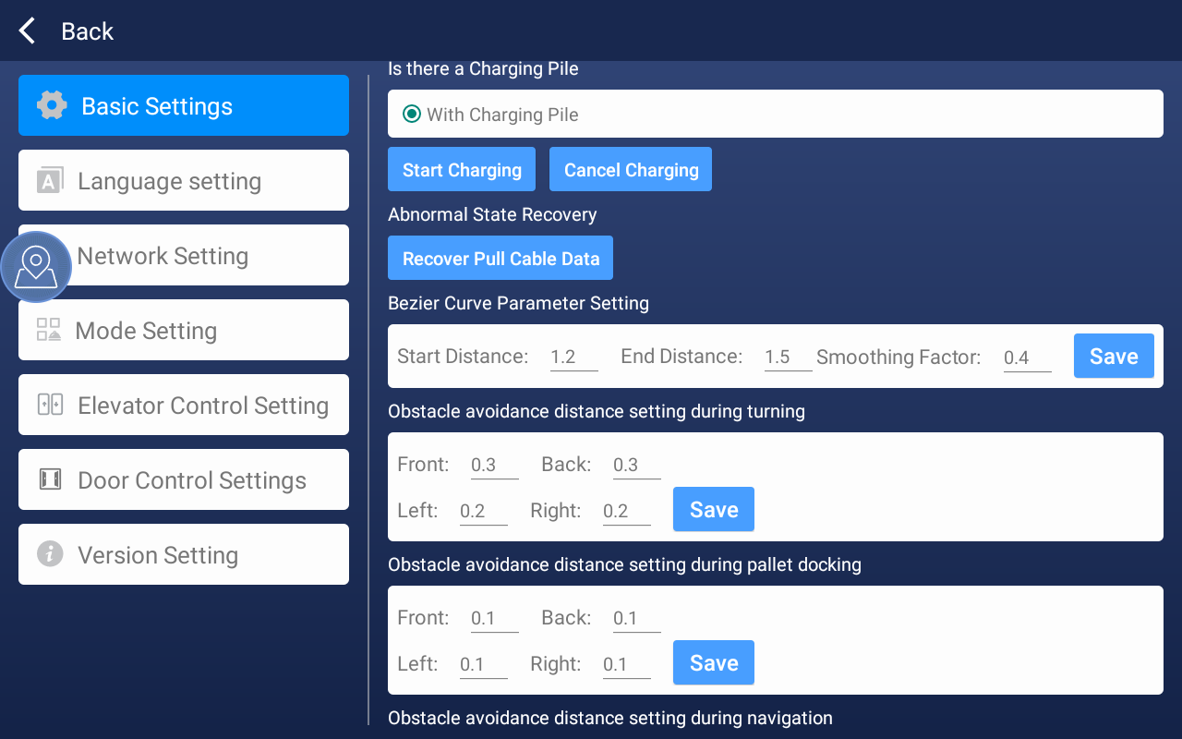
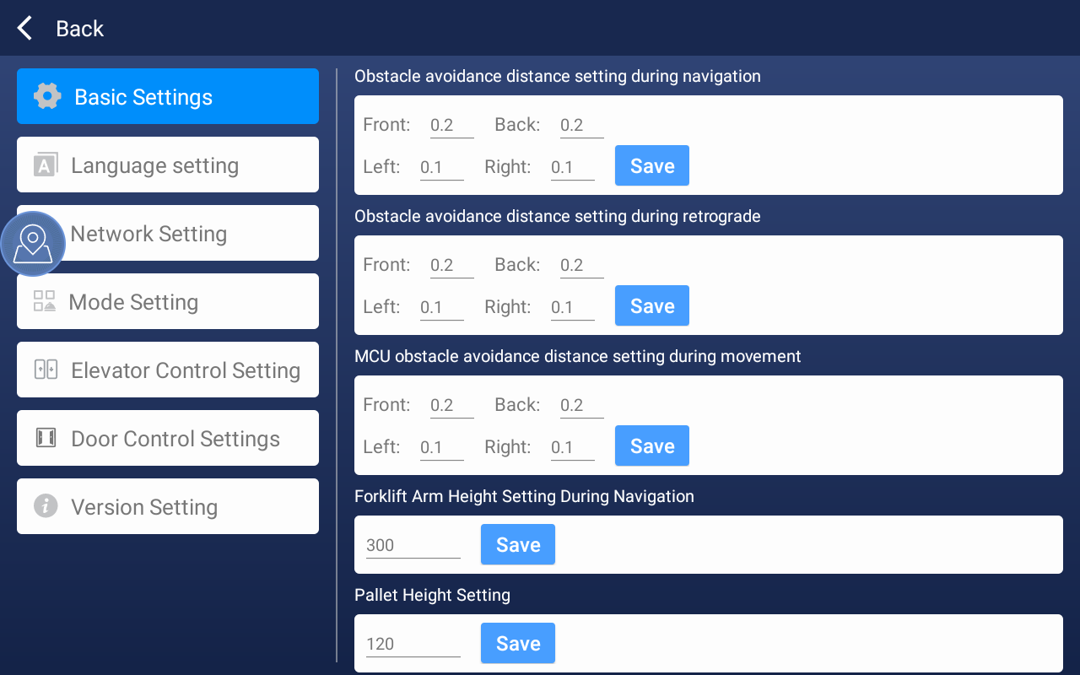
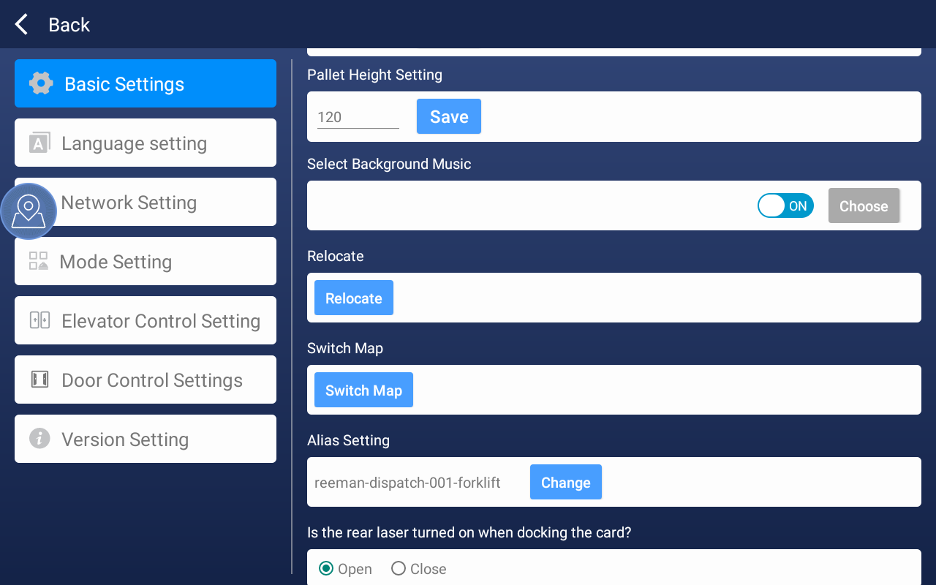
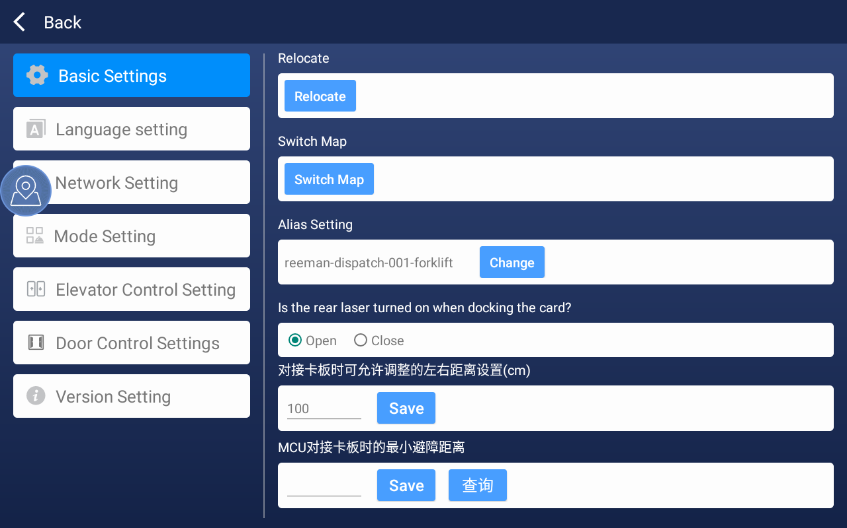
Media sound: The volume can be modified.
Screen brightness: The screen brightness can be modified.
Low battery setting: The standard for triggering low battery can be modified. When the power reaches this level, the machine will stop working and return to the charging station.
Shutdown low battery setting: The standard for triggering shutdown due to low power can be modified. When the idle state reaches this level, the machine will shut down.
Running speed: The speed at which the smart stacker runs can be modified.
Reverse speed: The speed at which the smart stacker reverses can be modified.
Turning speed: The speed at which the smart stacker turns can be modified.
Turn on obstacle avoidance prompt: You can choose to turn on or off obstacle avoidance prompt.
Administrator password: If turned on, you need to enter the password to enter the settings.
Pallet length: The default size of the pallet is 1.2m×1.2m. If it is a pallet of other sizes, please modify it before saving.
Machine steering setting: You can choose automatic steering or manual steering. When the forklift initiates navigation at a non-steering point, if the forklift direction deviates too much from the route direction, it will prompt steering or automatic steering.
Retry setting after encountering an obstacle when placing the pallet: you can choose to retry/not retry.
Retry times setting after encountering an obstacle when placing the pallet: times range: [1,65535].
Abnormal task end action setting: you can choose to stay in place/return to the production point/return to the charging pile. This setting takes effect in the following cases. After the task is triggered, a warning icon will be displayed in the navigation bar above the main interface at the end of the task. Clicking it will display the reason for the last task termination.
Whether it is equipped with a charging pile: the default is to have a charging pile.
Start charging: Click the button at the charging pile point, the charging pile will extend the charging arm to start docking. After the docking is successful and charging begins, the charging pile indicator light will turn red.
Cancel charging: Click the button when the machine is charging, and the charging pile will retract the charging arm to end charging.
Abnormal state recovery: you can recover the abnormal data of the pull line.
Arc turning parameter setting: the starting distance refers to the distance between the starting point of the arc and the turning point, and the end distance refers to the distance between the end point of the arc and the turning point. The smoothing factor range is [0,1]. The larger the value, the smoother the generated curve.
Obstacle avoidance distance setting when turning: You can set the obstacle avoidance distance when the machine turns.
Obstacle avoidance distance setting when docking pallets: You can set the obstacle avoidance distance when the machine docks pallets.
Obstacle avoidance distance setting when navigating: You can set the obstacle avoidance distance when navigating.
Obstacle avoidance distance setting when reversing: You can set the obstacle avoidance distance when the machine reverses.
Fork arm height setting when navigating: You can set the fork arm height when the machine navigates, the default is 300mm.
Pallet height setting: You can set the pallet height, the default is 120mm.
Obstacle detection setting in the pallet area: It is turned on by default. When it is turned off, obstacles in the target area will not be detected, and docking will be done directly.
Background music: After opening, you can click the selection button to display the music list. The music list will display the download/listen button according to whether it has been downloaded locally. The music list is uploaded from the web side `Settings`-`File Management`-`Distribution Mode`. If the music list fails to be pulled due to network reasons, it will check whether there are previously downloaded music files in the local directory. If there are, only the local music list will be displayed. You can select multiple points in the music list, and you cannot select undownloaded music.
Relocation: Clicking the relocation button will pull the points in the current map and list the `production point`, `charging pile`, and `entry point` (when the elevator control mode is turned on). After selecting one of the points, make sure that the machine is within a radius of 1m of the selected point and the angle error is less than ±30 degrees, then click relocation.
Switch map: Click to enter the map switching page, check the map and click Confirm to switch the map.
Alias ​​setting: When using the app for the first time, set the alias after connecting to wifi, and you can modify it here later.
When docking the pallet, is the rear laser turned on? It is turned on by default. If there is an obstacle at the bottom of the shelf and the goods on the shelf need to be forked, the rear laser needs to be turned off.
(2) Language settings - you can switch to other languages
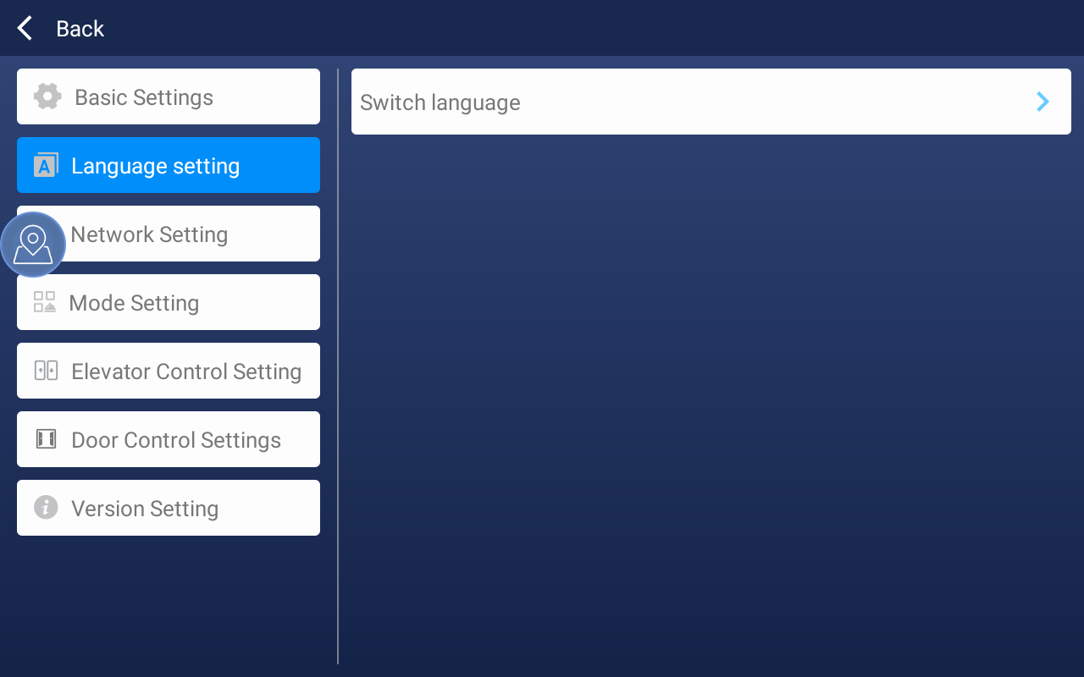

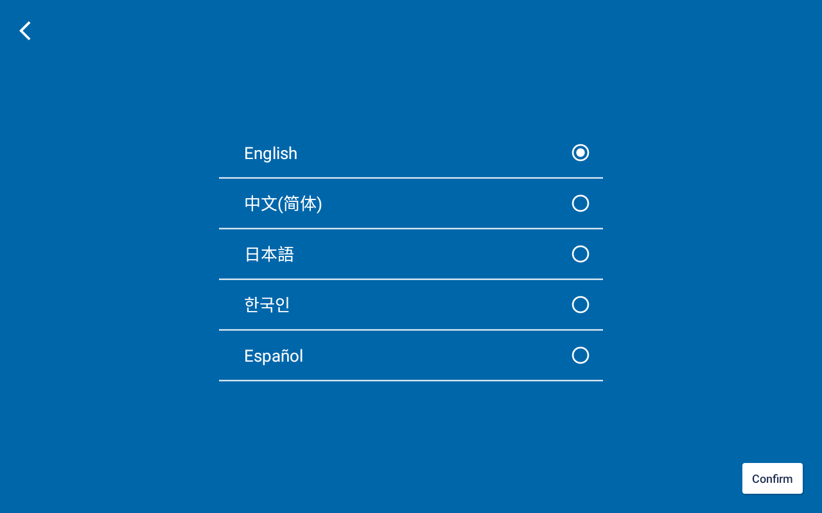
(3) Network settings-switchable network
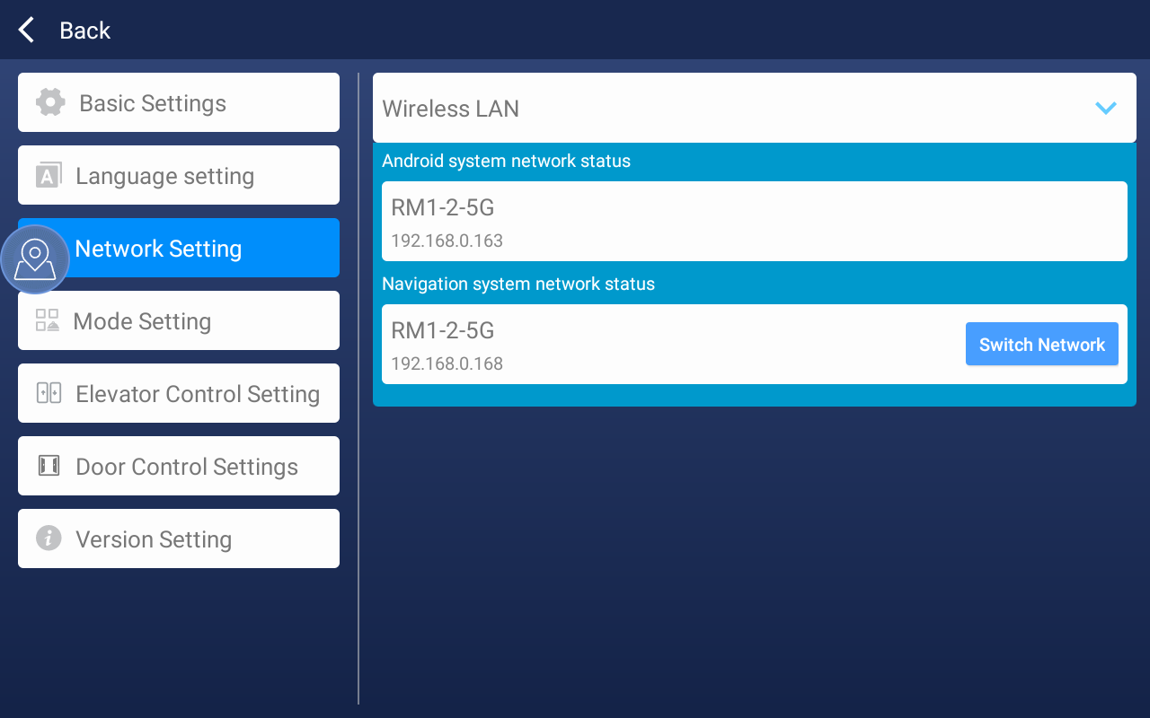
(4) Mode setting
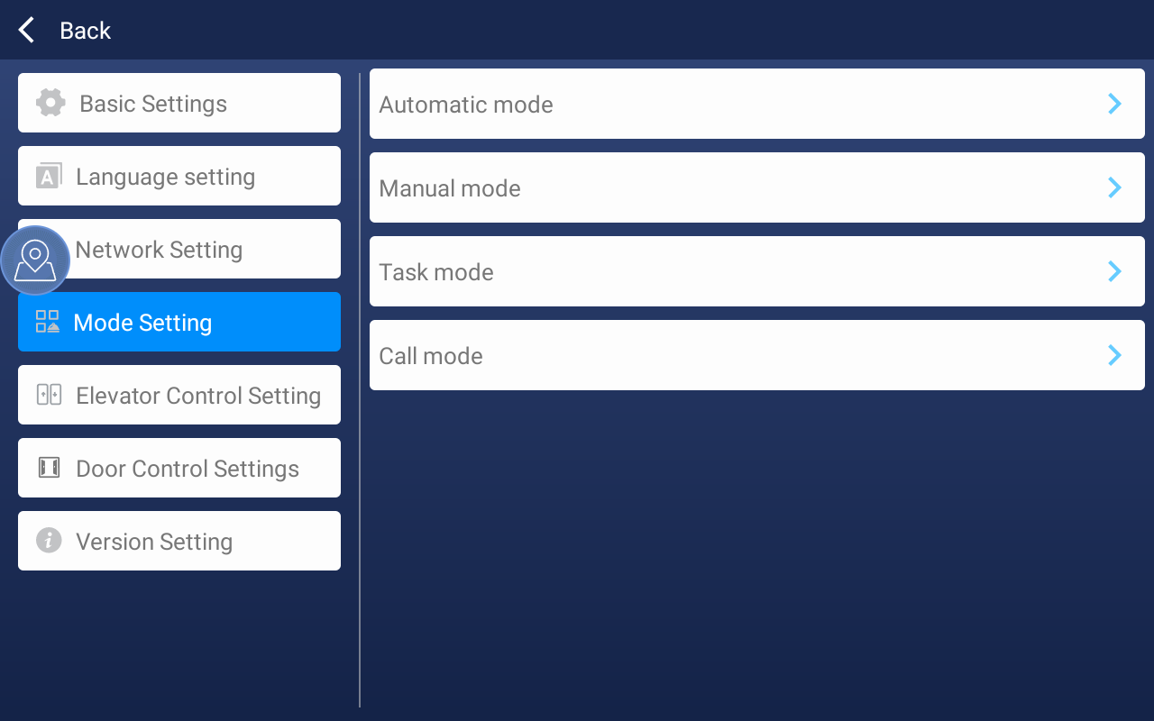
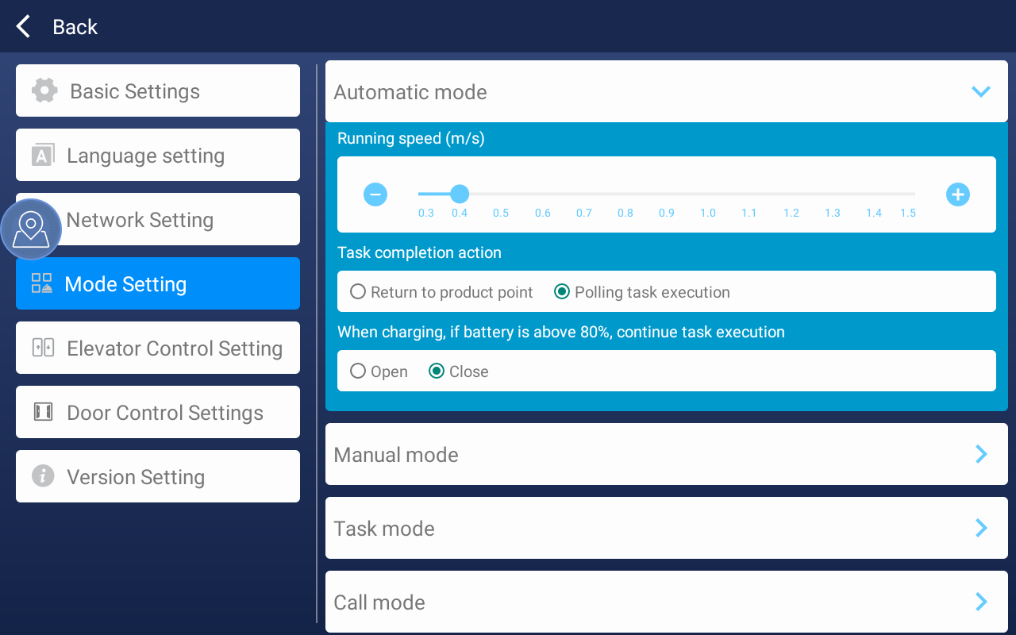
Automatic mode
Operation speed (m/s): The machine's automatic mode operation speed can be adjusted
Task completion action: You can set whether to return to the production point after delivery or continue the cycle task
While charging, whether to continue to execute the task when the power is higher than 80: This setting will appear when polling to execute tasks. After turning it on, the machine will continue to execute the task when it returns to the charging pile to charge when the power reaches 80% during the task execution.

Manual mode: The machine's manual mode operating speed can be adjusted
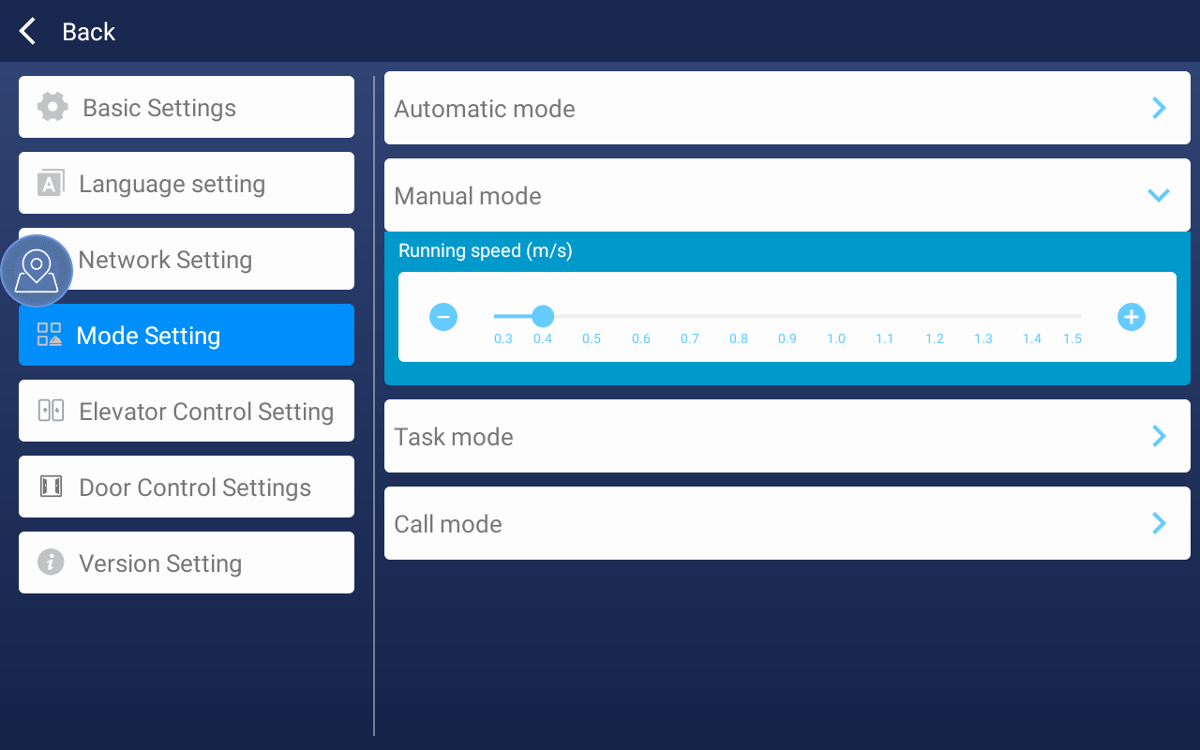
Task mode: The machine's task mode operating speed can be adjusted.
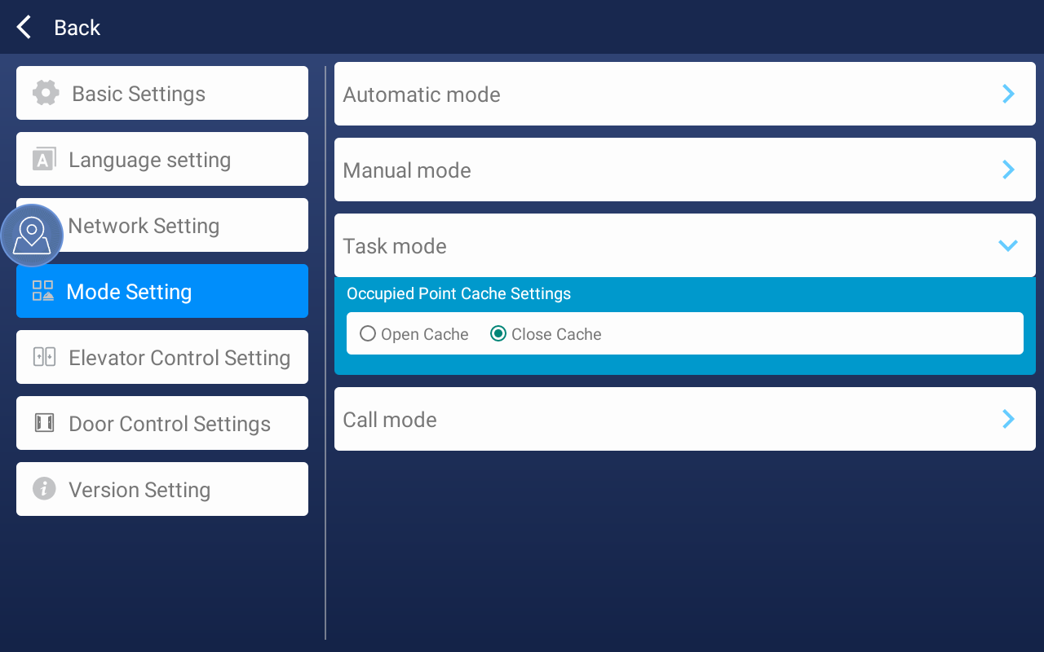

Call mode
Call module configuration: If the machine has a call module installed, you can bind the call button and point here (compatible with elevator control mode);
Running speed: The running speed of the machine call mode can be adjusted
Open one-key call queue: closed by default. After opening, if the stacker cannot respond to the call task immediately, the call task will be cached first;
Call task cache time: the time to cache the call task;
Call point dwell time: the time the forklift can respond to the call task again after arriving at the call point (this setting is to prevent the stacker from being called away by others immediately after arriving at the call location). When the call task ends, there will be a countdown on the main interface;
Pairing settings: The mobile application must be paired with the machine before the forklift can issue a task;
Secret key settings: After pairing, the data transmitted by the communication between the mobile terminal and the forklift will be encrypted using the secret key. After the secret key is changed, all previous pairings will become invalid;
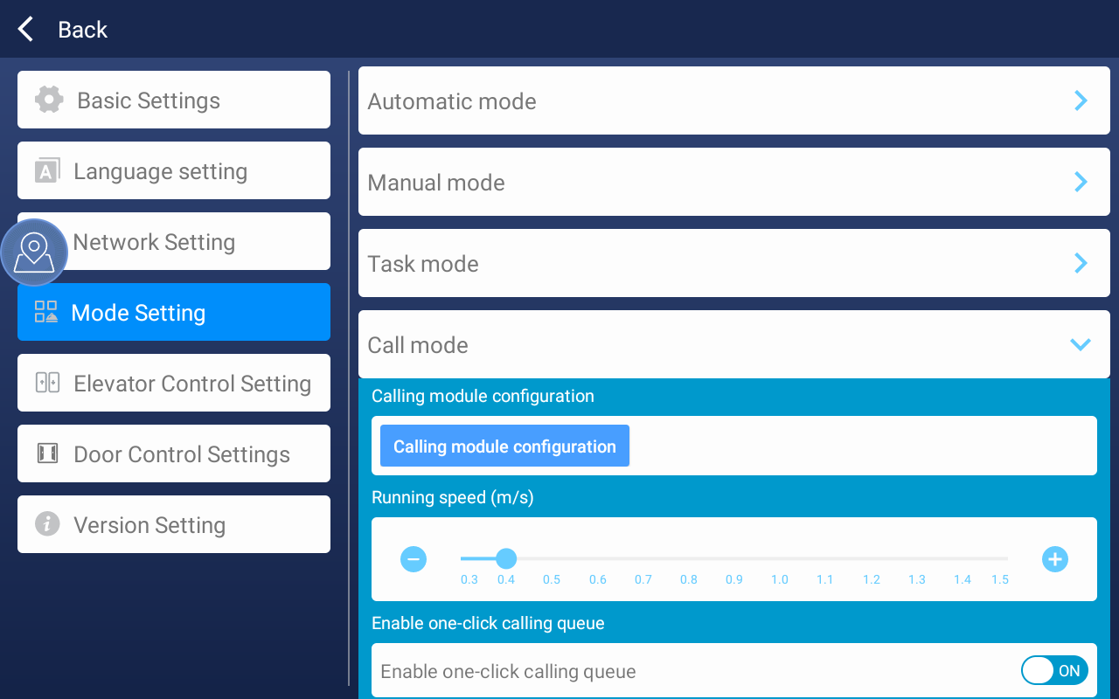

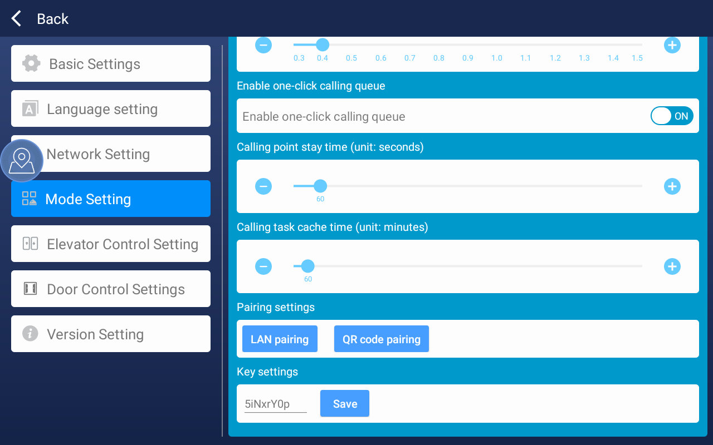

- Elevator control settings

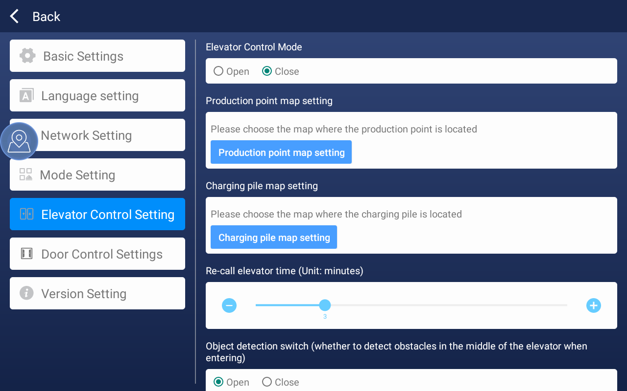
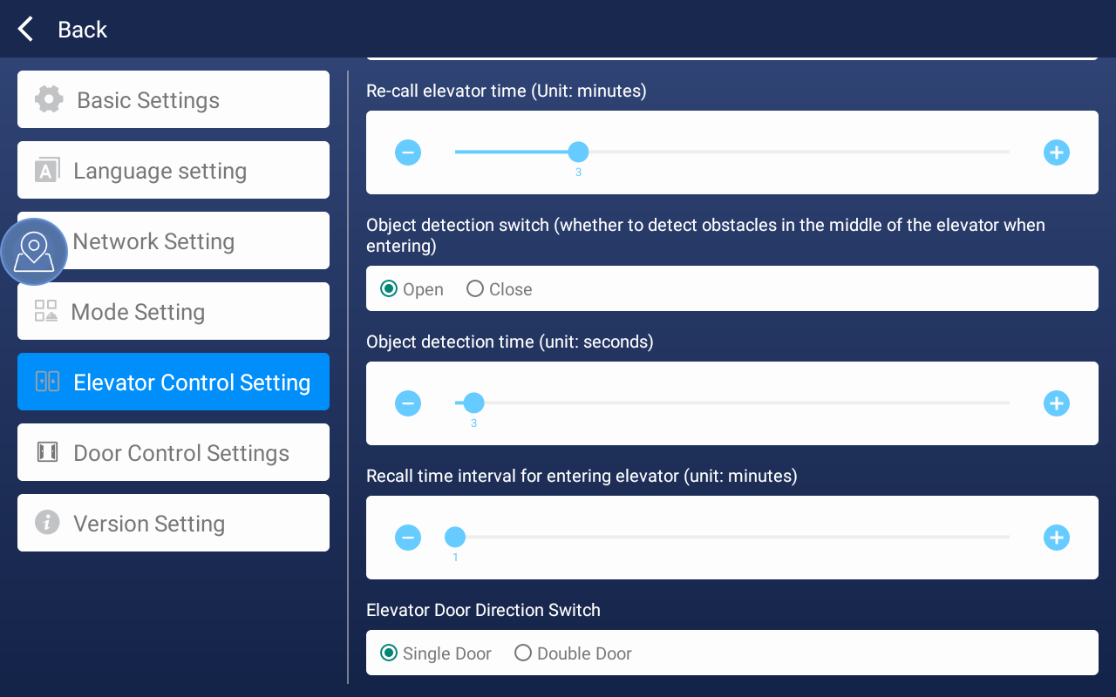
Elevator control mode: If the elevator control is installed on site, the elevator control mode switch needs to be turned on. If it is not installed, the elevator control mode switch needs to be turned off.
Set the map of the production point: Set the floor where the production point is located. After the robot completes the delivery task, the smart stacker will return to the production point on that floor.
Set the map of the charging pile: Set the floor where the charging pile is located. After triggering low power, the smart stacker will return to the charging pile position on that floor.
Timeout for re-calling the elevator: If the elevator call exceeds the set time, the smart stacker will re-call the elevator.
Object detection switch: When turned on, detect whether there is an obstacle between the machine and the elevator.
Elevator door opening direction selection: The default is one-way door opening. When two-way door opening is selected, the machine will use the exit point coordinates in the map of the target floor when exiting the elevator.
(6) Version settings
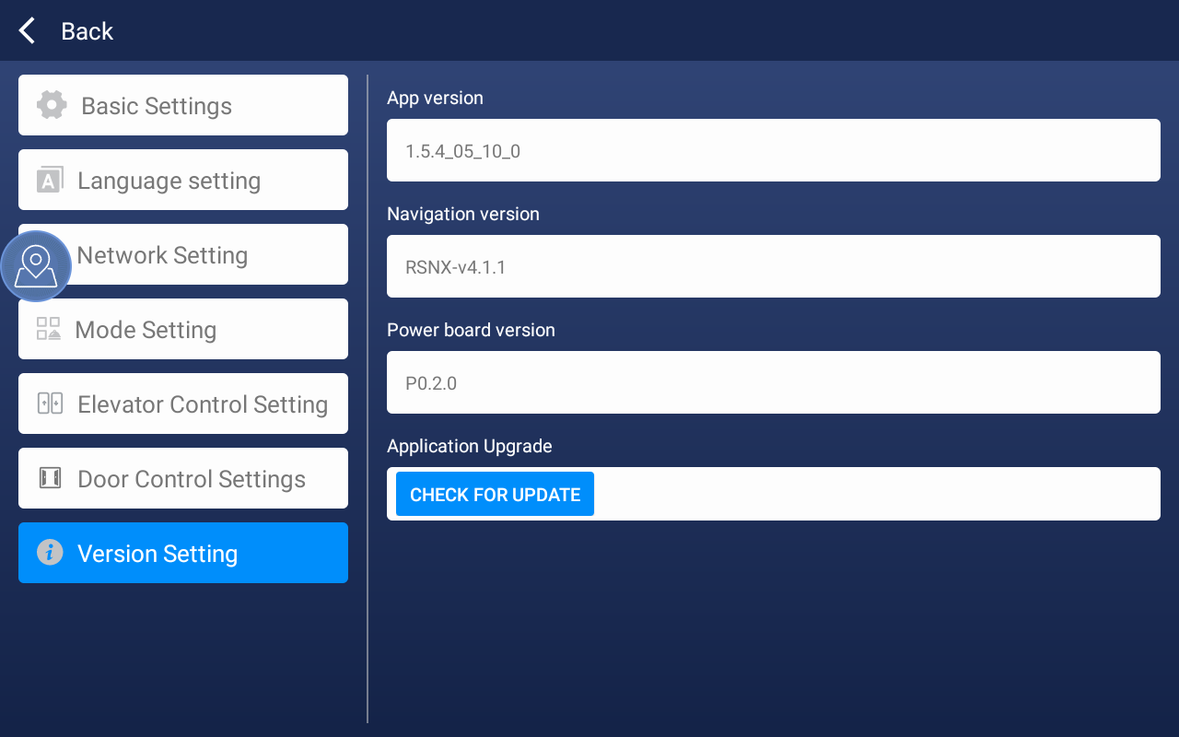
The first one shows the current APP version
The second one shows the current navigation version
The third one shows the current power board version
Application upgrade: After clicking Check for updates, the latest version number will be queried. If the current version is lower than the latest version, it will prompt you to upgrade

3. Explanation of other functions of the web terminal
3.1.【Edit Special Area】
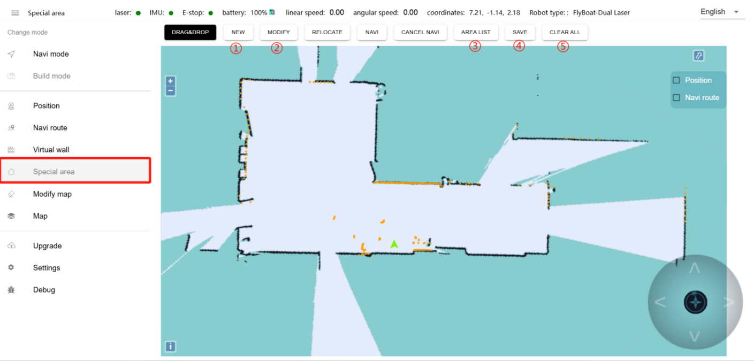
Function: You can draw an area to limit the speed of the robot in a certain area
① New: You can draw a polygon with the left mouse button on the map. After completion, a name box for the area will pop up, and you can define the area and speed
② Modify: Adjust the edited speed area. Click the speed area to be edited. The color of the area will change (the lines around the selected area will become thicker and red). At this time, you can drag the line to adjust the area size
③ Area list: After clicking, the edited area list will pop up on the right side of the page. You can redefine the speed and name of the area in the area list and delete the area
④ Clear: Clear all edited special areas with one click
Note: Currently not applicable to stackers

3.2.【Edit Map】
Note: This function is rarely used. Try not to edit or modify the map.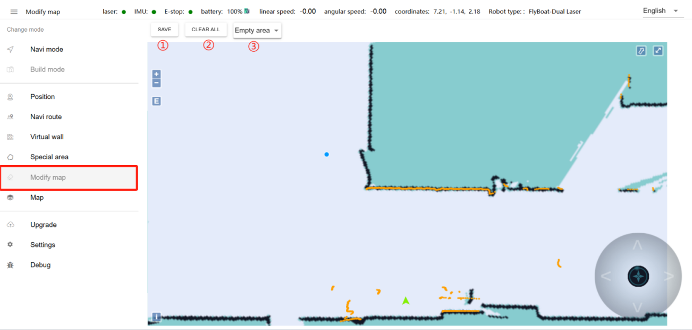
①Save: Click Save to apply changes to the map
②Clear: Clear the drawn polygon
③Blank area: Remove noise (such as noise left by pedestrians on the map during map scanning and temporary obstacles, etc.) Do not remove real obstacles as noise

3.3.【Map Management】
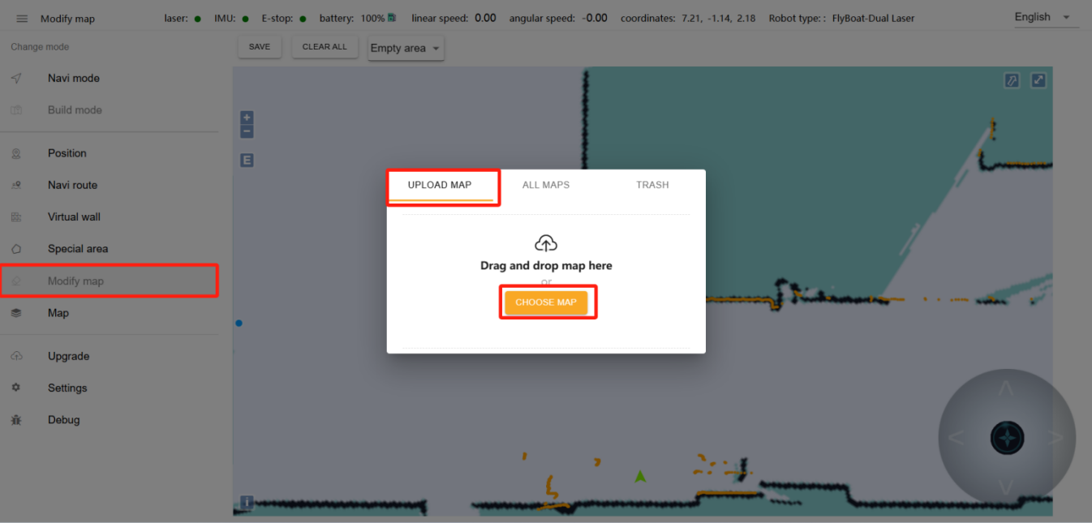
UPLOAD MAP:
CHOOSE MAP:You can upload maps exported from other robots in .png file format.Note: The map will not be applied immediately after it is uploaded. You need to find the map in [All Maps] and click the [Apply] icon.
ALL MAPS:
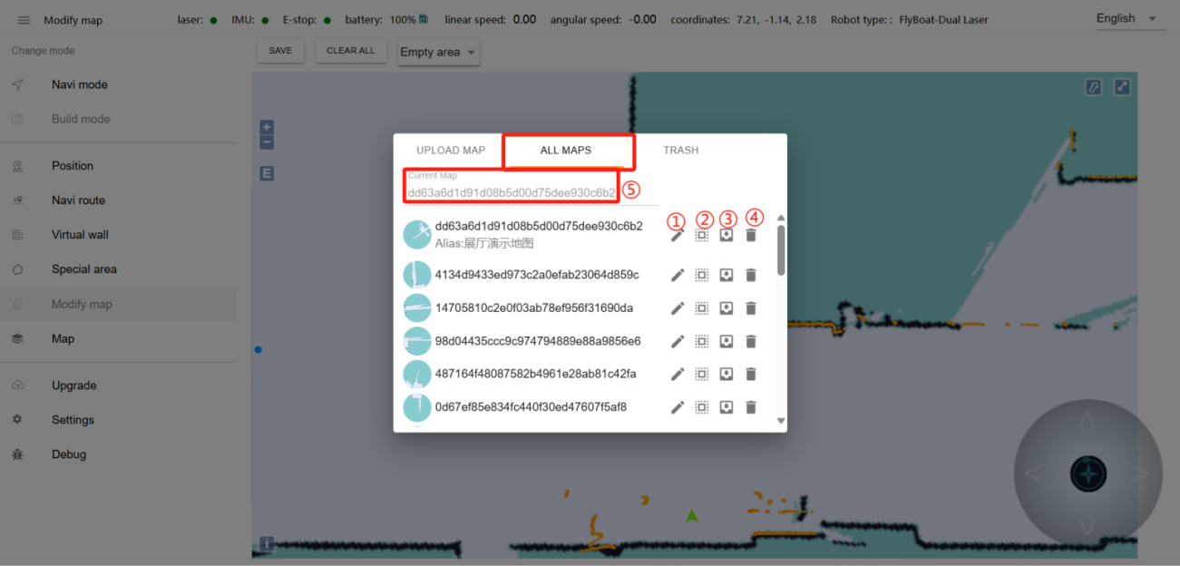
① Modify the map ② Apply this map ③ Export this map ④ Delete this map
⑤ Hover the mouse to display the preview map, click to display the original map
Note: The map will not be applied immediately after it is uploaded. You need to find the map in [All Maps] and then click the [Apply] icon
3.4.【upgrade】
Tip: We will upgrade the machine to the latest version before it leaves the factory. If you need to update the version later, follow the steps below.
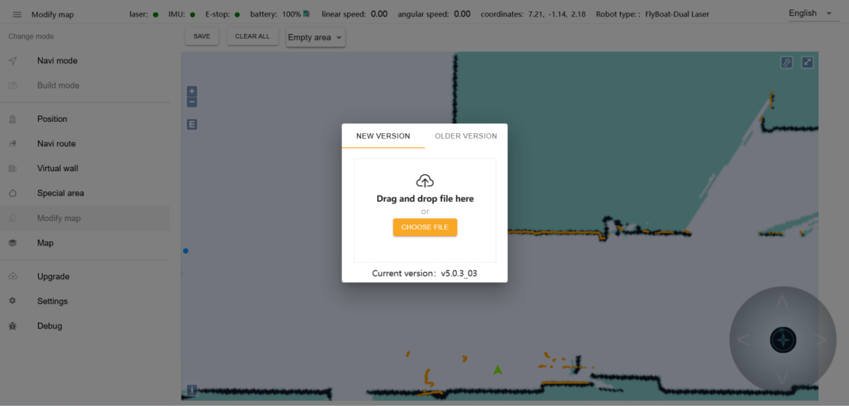

3.4.【Settings】
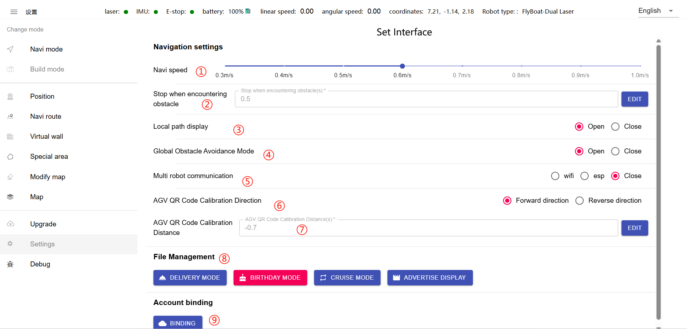
①Navigation speed: adjust the robot's travel speed (unit: m/s)
②Stop when encountering obstacle:Can Adjust the time the machine stays when encountering an obstacle.
③Local path display：This feature has been removed and can be ignored.
④Global Obstacle Avoidance Mode：When it is turned on, the robot will replan the global path when encountering an obstacle.
⑤Multi robot communication：You can ignore this. This is a feature of the old version. You don’t need to select it in the current version. Just choose to close it.
⑥AGV QR Code Calibration Direction:The direction of the machine when docking with the QR code. Forward direction: The robot's front direction moves toward the small QR code. Backward direction: The robot's tail direction moves back to the small QR code. (This function is only used for machines with a code reader)
⑦AGV QR Code Calibration Distance：The distance the machine withdraws from the small QR code. (This function is only used for machines with code readers)
⑧File Management：
DELIVERY MODE:Upload the background music file.After uploading, you can set it in IronOx software(Quantity: 20 in total, 1G for each audio)
BIRTHDAY MODE:Upload birthday mode background music file(This model does not have this function)
CRUISE MODE:Upload cruise mode background music files.(This model does not have this function)
ADVERTISE DISPLAY:Upload advertising pictures and video files (This model does not have this function)
⑨Binding: Bind the machine to the cloud platform management account
Note: The cloud platform management account is provided by the manufacturer.

3.5.【Debug】
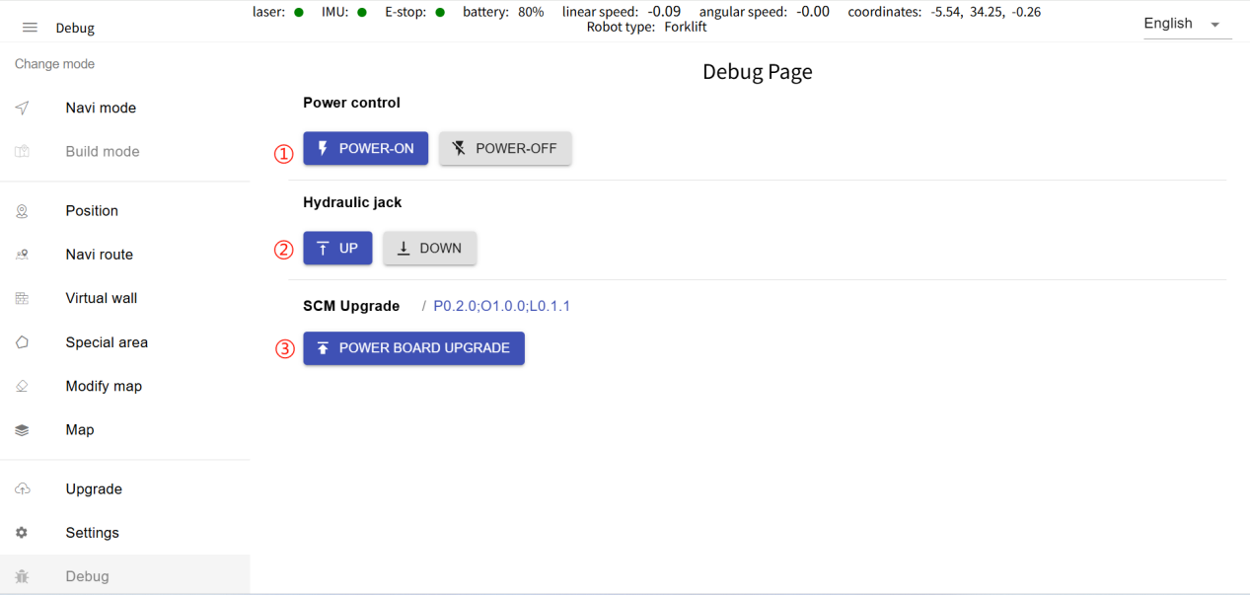
①Power control:
36V power on: can turn on battery voltage power.
36V power off: can turn off the battery voltage power supply.
② Hydraulic jack:
Lifting: A robot with a lifting module can be controlled to lift.
Descending: The robot with the lifting module can be controlled to descend.
③SCM Upgrade: Can display the power board version of the current robot
Power board upgrade: The robot is already the latest power board version when shipped, no upgrade is required. If you need, please contact the technicians.

4. Precautions for daily use
① Machine positioning is lost
Overview: Positioning loss refers to the mismatch between the machine's map location and the actual environment location.
Causes:
Loss of positioning caused by manually pressing the emergency stop switch to move the machine
During the movement of the machine, the machine will match the current map according to the actual laser data. If the current environment is too different from the map, the robot will fail to match the map, resulting in positioning loss. Positioning loss will cause the robot to lose its path planning ability and be unable to move
Someone blocking the scanning laser in front will cause the machine to lose positioning, and the matching degree between the laser and the terrain will become very low, resulting in loss of positioning

Solution:
Move the machine to the location of the charging pile and restart the machine within 2m of the charging pile (Note: the charging pile target point must be marked on the map)
Enter the map interface and manually issue a repositioning command

② The machine does not navigate
Overview: The machine does not navigate means that the machine navigates to a certain point and does not move
Causes:
● Check whether the emergency stop switch of the machine is turned on. The machine can navigate autonomously only when it is turned on (the emergency stop switch is turned right to indicate that it is turned on, and pressed to indicate that it is turned off)
● Check whether the machine has lost its positioning (the orange laser and the black obstacle on the map do not completely overlap, indicating that the positioning has been lost)
● Check whether the machine is close to an obstacle or a virtual wall (the machine cannot navigate if the machine is close to an obstacle or a virtual wall)
● Check whether the target point is close to an obstacle or a virtual wall
● Whether the machine deviates from the route by more than 1.5m (if the task is initiated when the deviation from the route exceeds 1.5m, the machine will not be able to execute)
Solution:
● If the positioning is lost, press ① Solution to the loss of machine positioning to reposition the machine
● If the machine is close to an obstacle or a virtual wall, move the machine a little outward
● If the target point is close to an obstacle or a virtual wall, reset the target point. When setting, it should be about 20cm away from the obstacle or the virtual wall

③ The machine navigation charging did not respond
Overview: The machine did not start navigating after sending the navigation charging command
Cause:
● Check whether the charging pile point was calibrated after the machine was docked with the charging pile and the charging pile button was used for calibration
● Check whether the charging pile target is close to obstacles or virtual walls
Solution:
● Please refer to the calibration method of the charging pile in [Calibration Position]
● Leave enough space in the direction of the charging pile route (to prevent the machine from not reaching the point)

④ Repositioning
Overview: Recalibrate the wrong position of the machine
Cause:
● The on-site environment is greatly different from that when scanning the map
● When the machine is working, the emergency stop switch is pressed manually, and the machine is moved to an area that has not been scanned and then moved back
● The machine is not turned on at the charging pile position (4.0 navigation has been upgraded to automatically match and locate when turned on. Few map feature points may cause long automatic matching time or matching failure)
Solution:
● Rescan the new map according to the latest on-site environment
● It is an incorrect operation to manually press the emergency stop to push the machine while the machine is running. Avoid this operation
Start the machine at the charging station

⑤ Laser noise
Cause: Dirt on the laser surface
Solution: Wipe the laser with a dust-free cloth

